



Landmark

Installation and Configuration

IBM Cognos TM1 10.2.2

Prepared by

Veracitiz Solution Pvt Ltd



**Document Revision History**

|  |  |  |  |  |
| --- | --- | --- | --- | --- |
| Version | Release Date | Author | Reviewed By | Comment |
| 1.1 |  | Vedant | Jacky/vikash |  |
|  |  |  |  |  |
|  |  |  |  |  |
|  |  |  |  |  |
|  |  |  |  |  |

**CustomerApprovals**

|  |  |
| --- | --- |
| Name | Title |
|  |  |

# **Contents**

1 Contents 2

1 Executive Summary 5

2 Application Role Description 6

3 Pre Installation Instructions 7

3.1 Software Download 8

3.1.1 IBM Cognos Software Download 8

3.1.2 Supported Software 8

3.1.3 Support Software Download 9

3.2 Server Installation Topology followed for Landmark TM1 Servers 10

3.3 Pre-Installation Steps, 11

3.3.1 Backups 11

3.3.2 Unzip and Copy the Software to All the Servers 11

3.3.3 Check the server configuration and Hostname 12

3.3.4 Configure Microsoft .net Framework/.net extensibility 13

3.3.5 All TM1 Servers and Admin Machines 13

3.3.6 Configure the IIS Webserver for Cognos BI Url 14

3.3.7 Install MS Office 2007 or 2010 32 Bit version on the server/local machine we need to install with the TM1 Perspective 16

3.3.8 Firewall Port opening, 17

4 Installation of Softwares 18

4.1 Installation of Oracle 11g Client 18

4.1.1 Installation location 18

4.1.2 Install Oracle client 19

4.1.3 Steps for setting up the Oracle 11g 20

4.2 Installation of Cognos BI 25

4.2.1 Install Cognos BI server Components 25

4.2.2 Configuration of BI Server 30

4.2.3 Configure the Active Directory Namespace to the BI Security 32

4.2.4 Configure the Content Store 35

4.2.5 IIS Configuration to start the BI Gateway (10.110.13.147) 38

4.2.6 Test both the URL after starting the Cognos BI services 45

4.2.7 Configure BI to accept TM1 Web server requests (BI-TM1 inter-compatibility) 46

4.3 Installation of Cognos TM1 along with Fix pack 3 50

4.3.1 Install Cognos TM1 Server Components 50

4.3.2 Configure the IBM Cognos TM1 Components 55

4.3.3 Upgrade the TM1 10.2.2 with the Fix Pack3 58

4.3.4 Run the Architect Client 61

4.3.5 Run the TM1 Application and TM1 Web for the first time 63

4.3.6 Add new TM1 Server as Landmark_Prod 64

4.3.7 Change the TM1 Server to point to IBM Cognos BI Security 68

4.3.8 Update TM1 Application Config file to accept the BI Urls 74

4.4 Configure Cognos BI on SSL 75

4.4.1 Import the certificates in to the respective trust stores 75

4.4.2 Import Certificate to Windows Key Store 76

4.4.3 Update the IIS settings 79

4.4.4 Change the URLs in Cognos Configurations 81

4.4.5 Check BI URLs with SSL 82

4.5 Configure Cognos TM1 Web Application Server on SSL 84

4.5.1 Create a Certificate Key in the New Keystore. 84

4.5.2 Create the Certificates requests 85

4.5.3 Certificates from CA 85

4.5.4 Import the certificates in to the respective truststores 86

4.5.5 Change the URLs in Cognos Configurations 87

4.5.6 Change the URLs in config files 89

5 Additional Installations and configurations 93

5.1 The User Guide for the End user’s 93

5.1.1 The Production server Access 93

5.1.2 The Development server Access 93

6 Trouble shooting 94

6.1 Cryptography Error while saving the TM1 IBM Cognos Configurations 94

6.2 If the Server is not registered in PM 95

6.3 If Application is not appearing in the web-apps 96

6.4 Perspective error 96

6.4.1 File Missing 96

6.4.2 Compatibility Issue 97

6.5 The Port Opening Issue 97

Executive Summary

This document describes the installation process for the below listed applications;

1. IBM Cognos TM1 – This installs the complete TM1 components which includes the Development and production server Installation and Configurations

Step by step installation instructions are given in the following sections including screenshots. Any settings and configuration steps are also listed. This provides the engineer with enough information to carry out an install of the application on a new server or PC and migration from existing to new environment.

1. Application Role Description

IBM Cognos TM1 applications is the Web based planning and budgeting solution developed for all the business planning team users across the Landmark location all over the world. The software has released new versions IBM Cognos TM1 10.2.2 with FP3.

1. Pre Installation Instructions

This section details the process to install the application. All steps are recorded in screen shots if applicable and any required settings are shown in the screen shot or are shown in text. After the installation, any extra configuration steps and tidy up steps are also listed. The Steps mentioned are specific to the environment Landmark.

Software Download

IBM Cognos Software Download

Download the following software from IBM Passport Advantage site with registered ICN.

Go to the URL - <http://www-01.ibm.com/support/docview.wss?uid=swg24029277>

Select the passport advantage link on the page and login with the IBM ID and download the Cognos Planning product code as per below site

Download Complete Installation Kit from the passport advantage site,

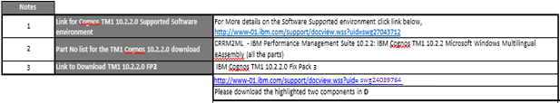

IBM Cognos TM1 10.2.2 Fix Pack 3

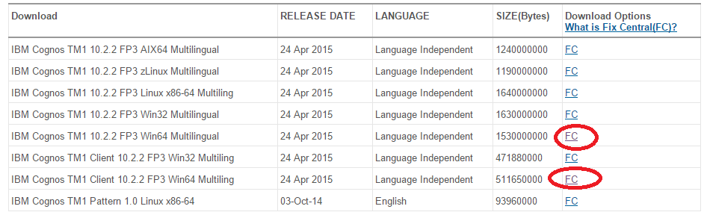

<http://www-01.ibm.com/support/docview.wss?uid=swg24039764>

Please download the highlighted two components in **Download Package** Section of the web page

Supported Software

IBM Cognos TM1 10.2.2 supported environment,

[http://www-969.ibm.com/software/reports/compatibility/clarity-reports/report/html/osForProduct?deliverableId=1403637468919#](http://www-969.ibm.com/software/reports/compatibility/clarity-reports/report/html/osForProduct?deliverableId=1403637468919)

Support Software Download

* Update server Windows OS with Latest Patch
* Download .Net Framework 3.5.1 SP1 software
* Download MS Chart Control for .Net Framework 3.5.1 SP1
* Microsoft Visual C++ 2010 Redistributable Package
* Download MS Office 2007 or 2010 32 bit version for MS Excel Client Components
  1. Server Installation Topology followed for Landmark TM1 Servers

Development Server/Production Server

|  |  |  |
| --- | --- | --- |
| Server | Server Type | Components To Be Installed |
| A  (10.110.13.147) | 1 Virtual Server(VM) | TM1 Web, BI Gateway will be installed on this server.  SSL Enabled |
| B  (10.110.13.133) | 1 Physical Server | TM1 Admin, TM1 Application Server (Not to configure SSL) |
| C  (10.110.13.148) | 1 Virtual Server(VM) | BI Application Server, BI Content Manager will be installed on this server.  Oracle DB for Content Store will also be installed. (Not to configure SSL) |

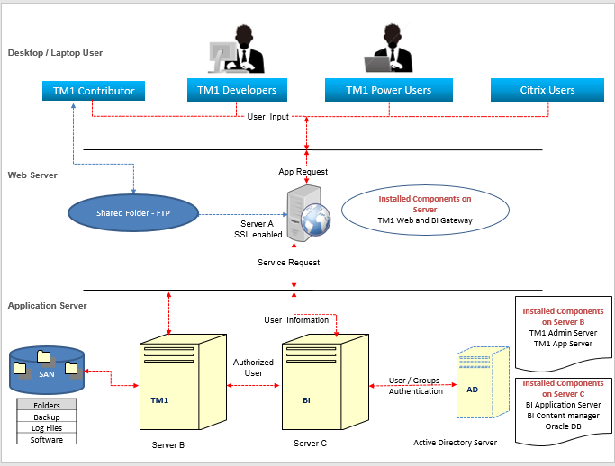

* 1. Pre-Installation Steps,

Backups

Since this is a new installation we do not need any backup related activity for these servers

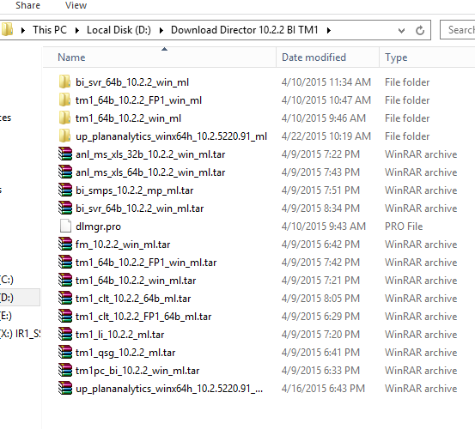

Unzip and Copy the Software to All the Servers

Check the server configuration and Hostname

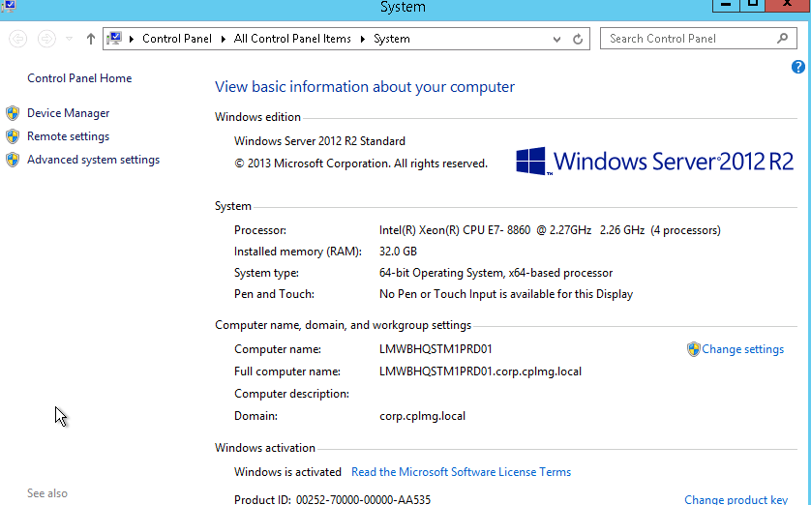

System Details:

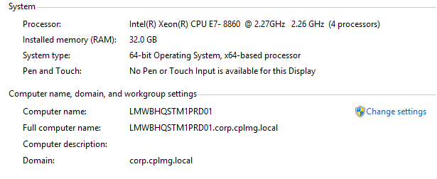

Configure Microsoft .net Framework/.net extensibility

All TM1 Servers and Admin Machines

Microsoft .net Framework 3.5.1 is supplied on the Windows Server 2012 OS as a Feature we can add this through the Control Panel path.

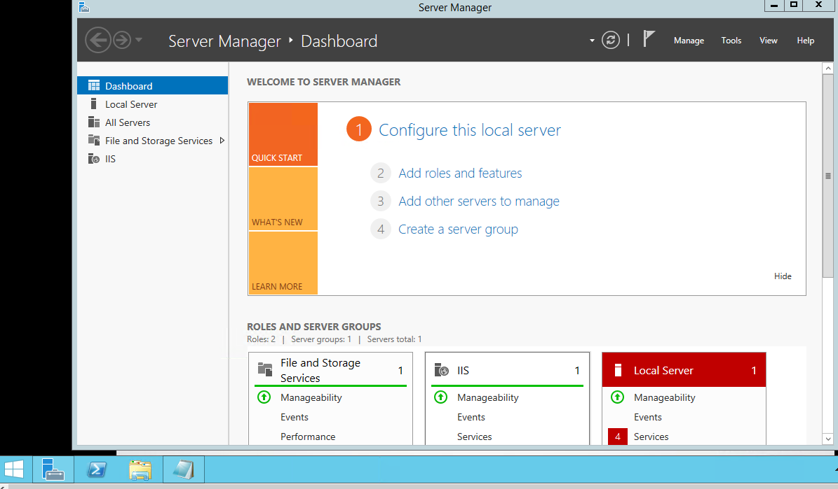

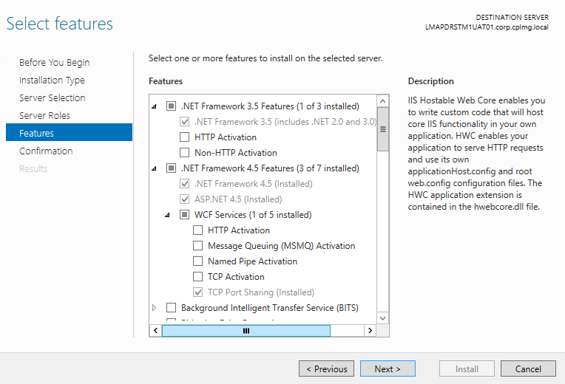

Select the features one by one as shown in the diagram. And finish the installation

Configure the IIS Webserver for Cognos BI Url

Microsoft IIS (internet Information Service) is supplied on the Windows Server 2008 OS as a Role Service we can configure this through the Control Panel path.



Select all the required components for IIS webserver to configure

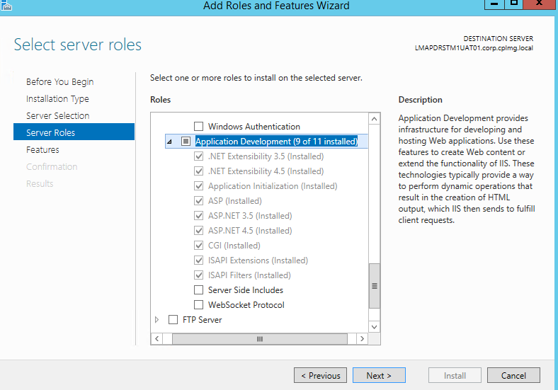

Do Next and Install.

Finish the configuration.

**Restart the Machine after following activation of the Feature and Roles**

Install MS Office 2007 or 2010 32 Bit version on the server/local machine we need to install with the TM1 Perspective

Make sure if 32Bit version is been used for the Excel, install client with the same version because later on it can give the error for the TM1 Perspective.

Firewall Port opening,

To enable the server communication with other servers and end users following ports are required to open in the Network.

Ports Between All Cognos Servers and All End User / Admin User Machine

Universal ports to be opened for all Servers and Users,

80 – IIS

443 – IIS on SSL

9510 – TM1 Application Non SSL

7999 – TM1 Application on SSL

Ports Between All TM1, All BI servers and Admin Machines

Same as mentioned in the above point #

9300 – BI Dispatcher

5498 – TM1 Admin Server on SSL

5495 – TM1 Admin Server on Non SSL

17270-TM1 Server (Development Server)

31341 … 31390 - TM1 Server (Production Server)

Ports between AD server and All Cognos servers

389 – AD Service port Non SSL

636 – AD Service port on SSL

Installation of Softwares

Installation of Oracle 11g Client

Installation location

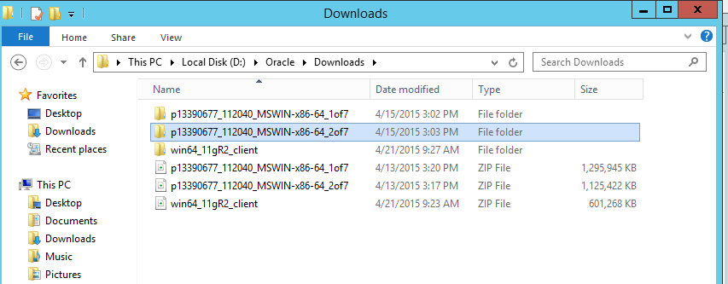

Extract the required files . Now go to the folder p13390677_112040_MSWIN-x86-64_2of7

and travel to

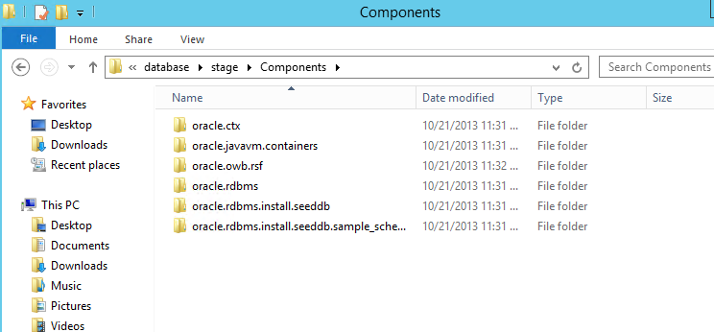

Copy all this files and past in the below location.

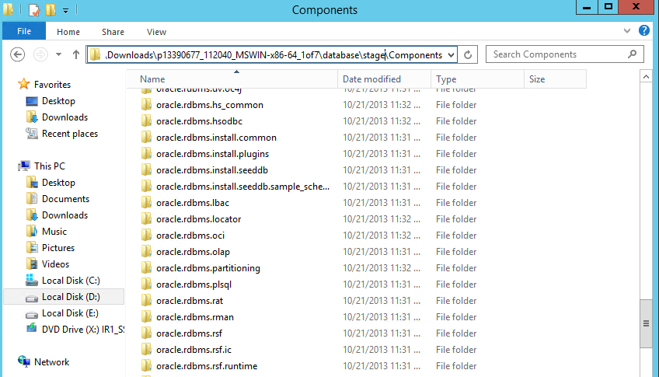

Install Oracle client

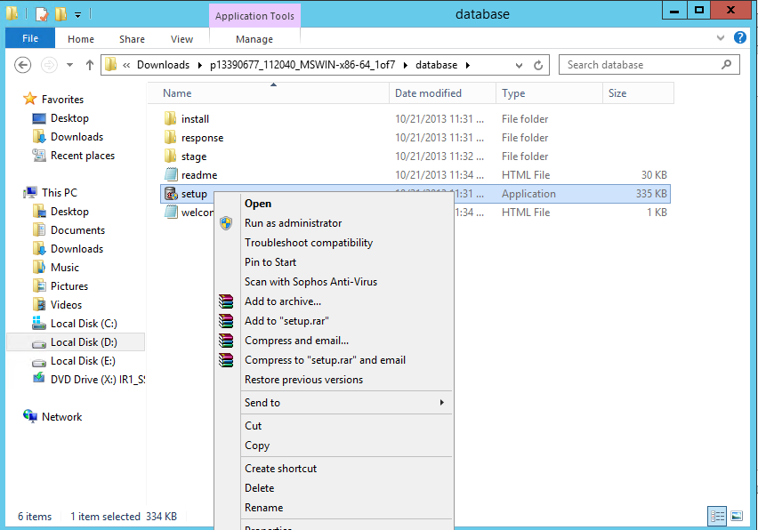

Right click the Setup file and run it as Administrator.

Steps for setting up the Oracle 11g

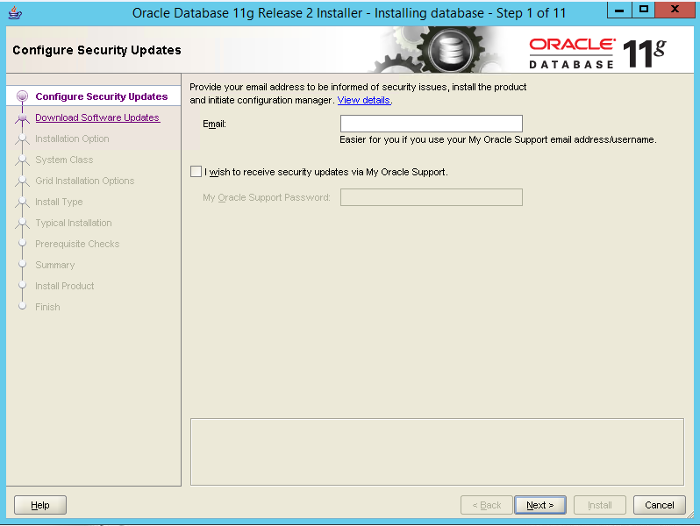

11 Step setup is there which you need to follow. As you see the 1st step click next without entering the Email ID. It will prompt the warring but continue.

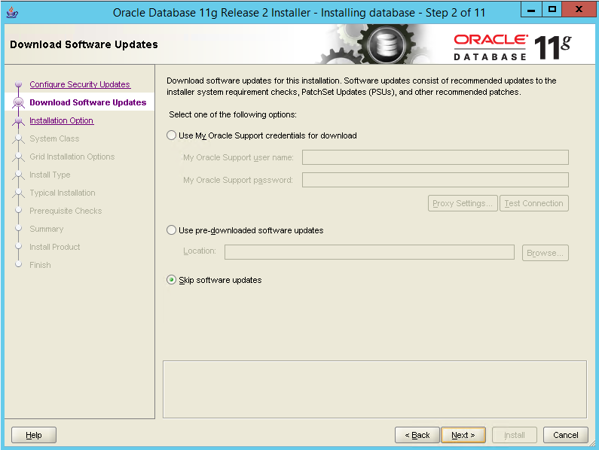

Skip the Software updates

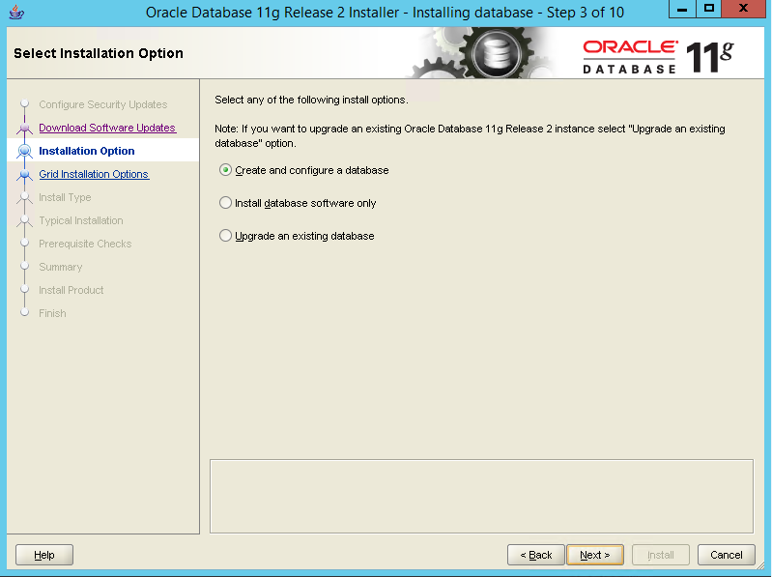

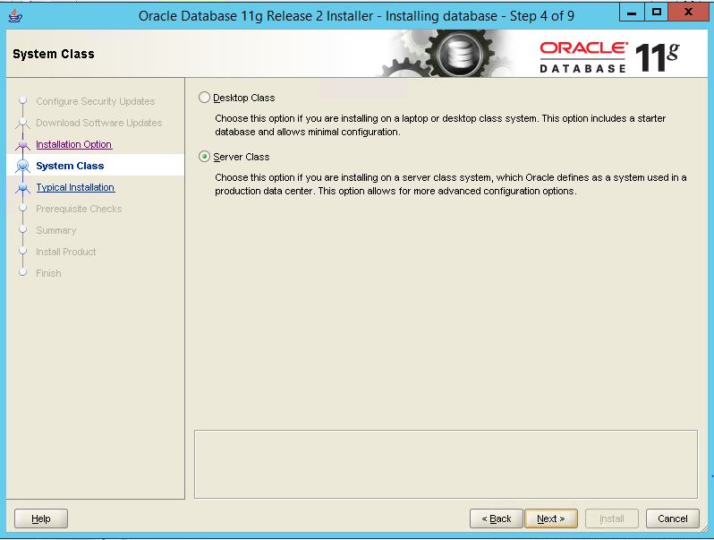

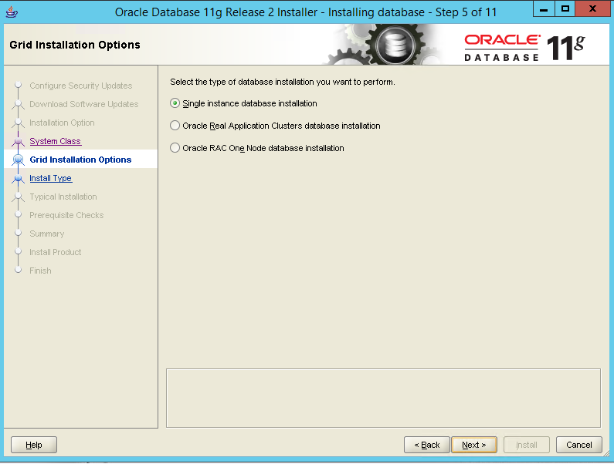

Select the Single instance Database Installation

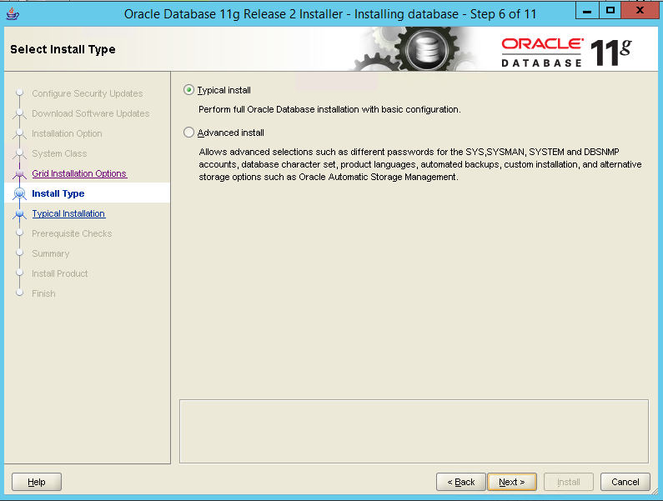

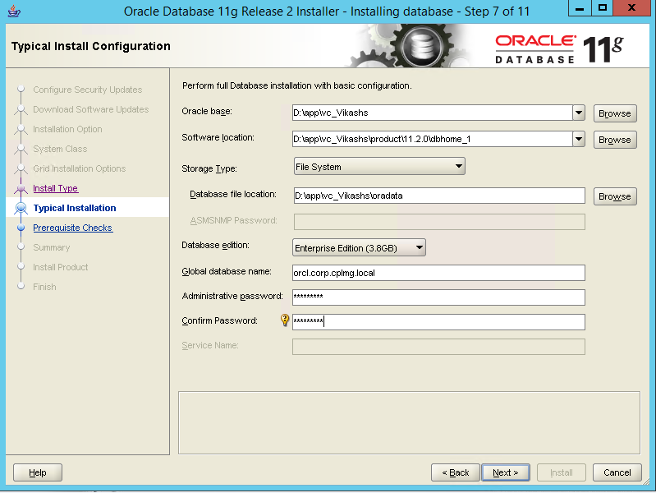

Change the Install Directory if needed and give the database name and the admin password for the same.

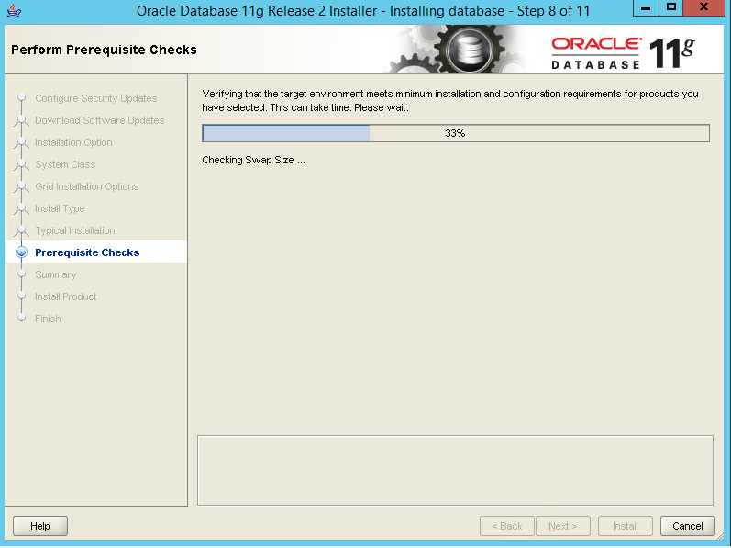

Check the summary of the Install Products and see that no error is prompted. Finish the Installation process.

Installation of Cognos BI

Install Cognos BI server Components

Go to software folder and open the BI installation kit



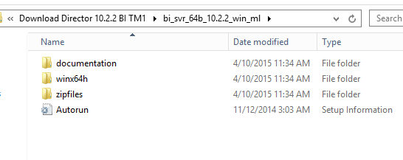

Navigate to win64> issetup.exe Run with “Run As Administrator” option on right click it

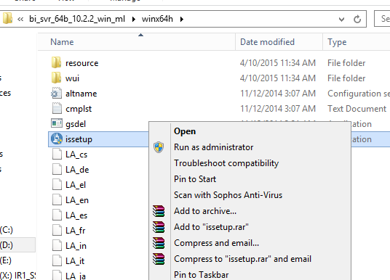

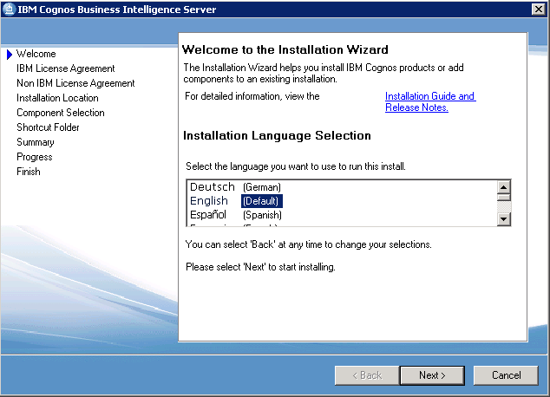

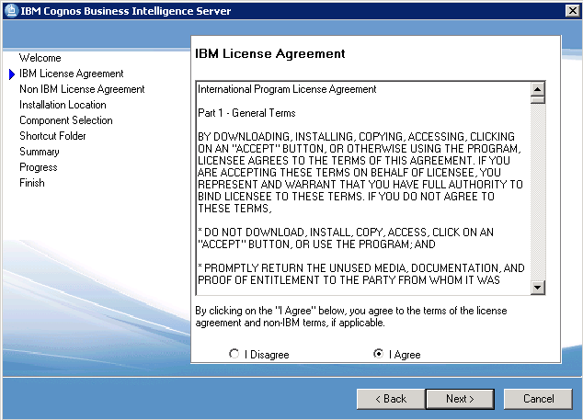

Change the Installation Drive as per requiremnet but do not change the folder path behind it.

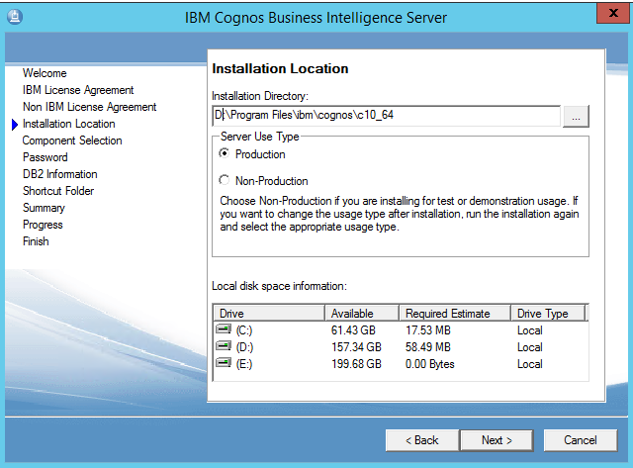

Select all the components for single Server installation else for distributed architecture, follow the below steps.

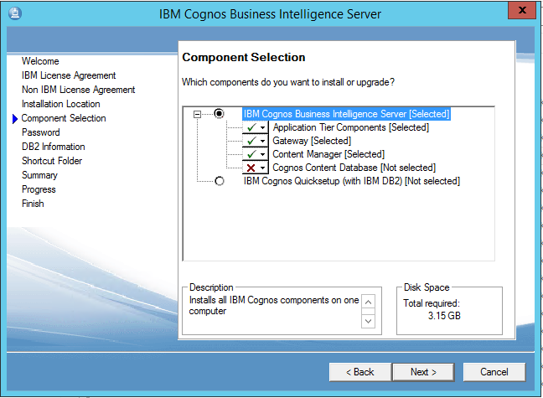

**Web Server/Gateway server** – Select Gateway

**Content Server** – Select Content Manager (Cognos Content DB is optional for Content store config)

**Here at Landmark we have Oracle Database configured with the Cognos**

**Application /Dispatcher Server** – Select only Application Tier Components

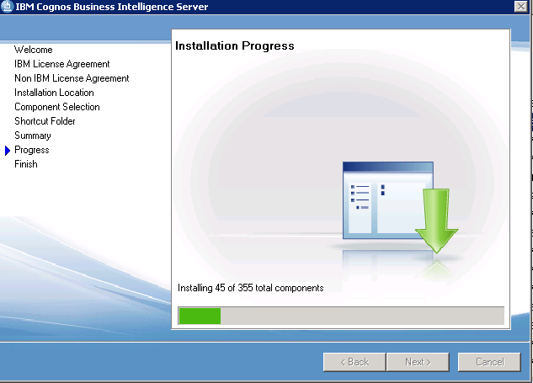

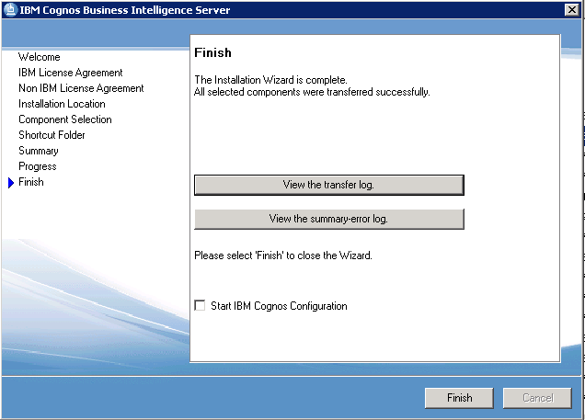

Finish the installation

Configuration of BI Server

Update all the Localhost URLs with the Server name and Host name **Save** the changes.

Change <http://localhost:80/ibmcognos/cgi-bin/cognos.cgi> to

[http://lmcgsweb.cplmg.com:80/ibmcognos/cgi-bin/cognos.cgi](http://s185a0099:80/ibmcognos/cgi-bin/cognos.cgi) and same way for the all.

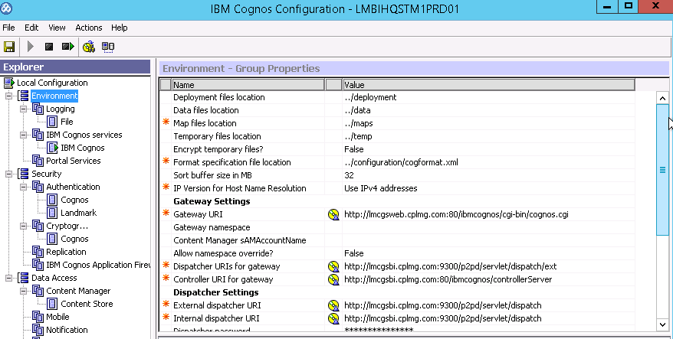

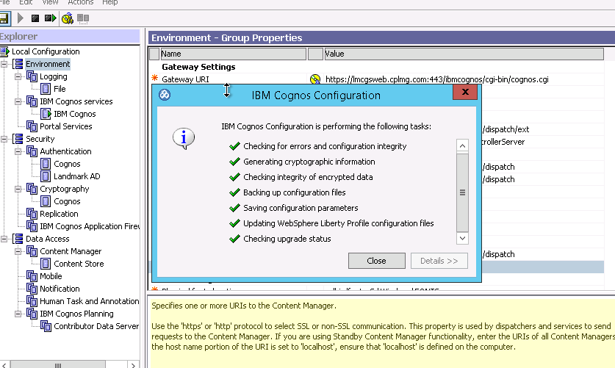

Save the Configuration after the update of the URL's and then start the cognos configuration as below.

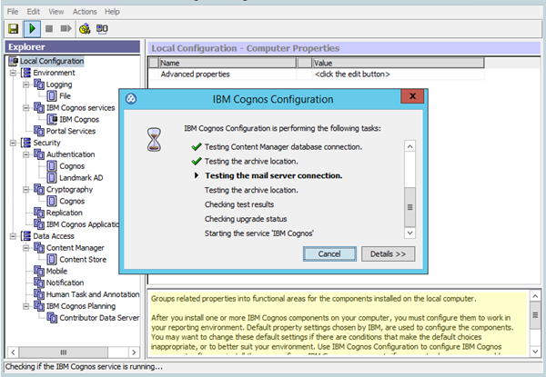

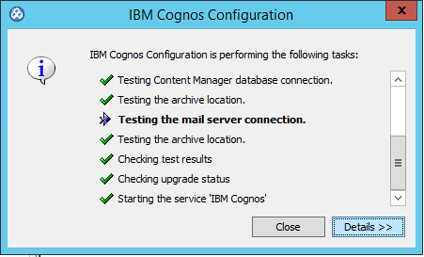

Click OK for the warring message appears for the Mail Server connection and then click continue as we have not configured the mail server. Click close when done with the saving.

Configure the Active Directory Namespace to the BI Security

Open the IBM Cognos Configuration of the server where Content Manager Component is installed,

Add New Resource to Authentication tab,

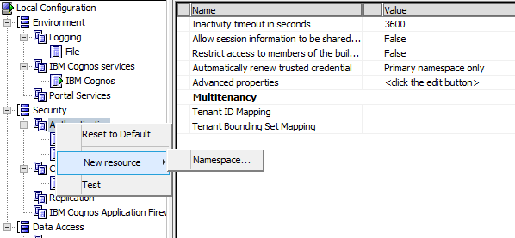

Name the Namespace which will be later appear along with Cognos Namespace and Select the provider as Active Directory.

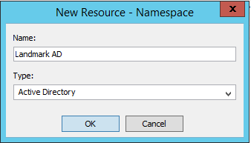

Provide the required AD server credentials and the Binding credentials to connect the AD server with the Cognos Server.

**Namespace ID:- Landmark AD**

**Host and port :- lmdcaedr1.corp.cplmg.local:389**

**Binding credentials:- user id: cognos.user ; Password: yAD75hnb4dIFbWXCE**

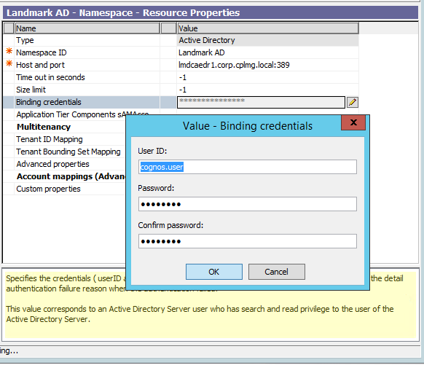

Test the configuration for the Namespace added, by right click on the namespace name,

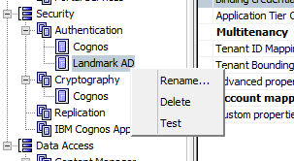

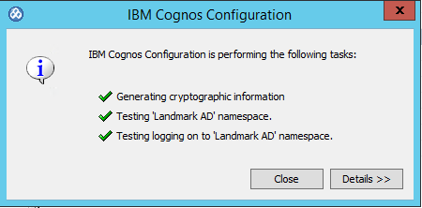

When tested successfully this screen would appear.

If test is not successful there are following reasons for the same,

* Check the IP and Port for the AD server
* Check the Credentials of Binding User Name and Password
* Check the telnet with Server and AD Sever on given port
* Check the Firewall policies to Domain registered on AD Server as well as Cognos Server
* Or there might be the Server issue/Drop downs which might be causing it.

**Note:- Make sure that the binding credentials which are added with the AD configuration are not changed , but if in case it is been changed then you will have to update it here also and then restart the IBM Cognos Services.**

Configure the Content Store

Open IBM Cognos Configuration and right click on the Content Store.

Delete the Content store which is already created.

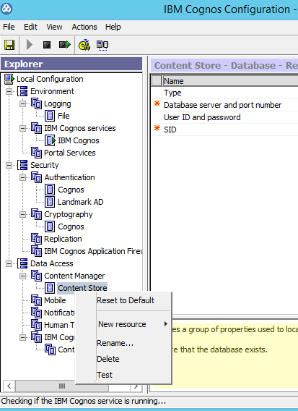

Right Click on the Content Manager to Create a Content Store

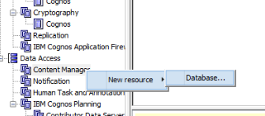

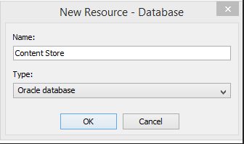

**Create the new Content Store with the type** Oracle Database.

Add all the required details and test the connection.

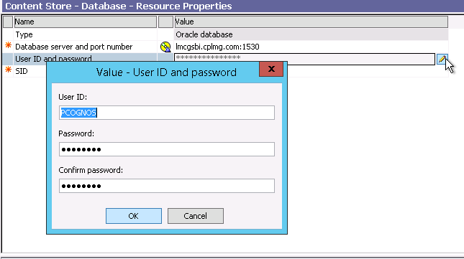

You can also check it from the URL mentioned below to see if the content store is running or not.

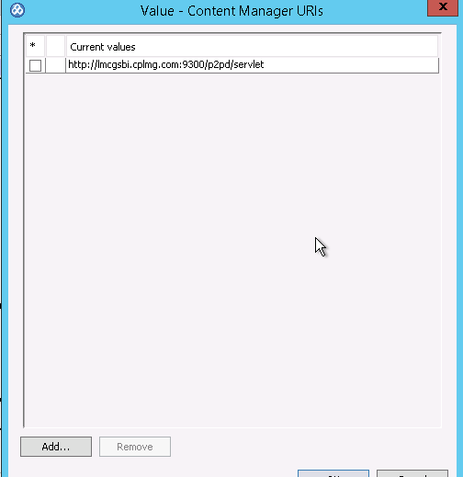

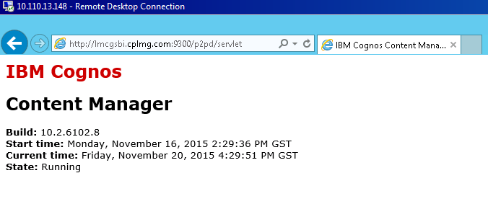

IIS Configuration to start the BI Gateway (10.110.13.147)

Open IIS from All programs > Start > run

Create Virtual Directories

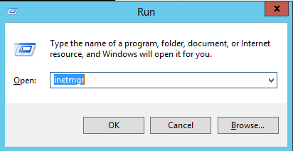

Or open

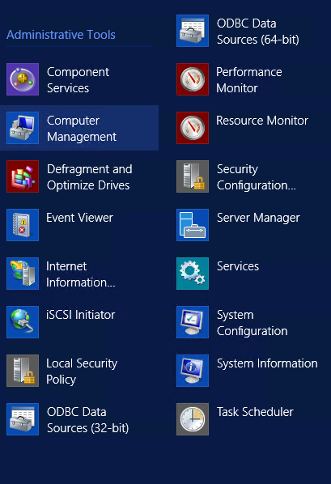

Open as Run as Administrator

Add Virual Directory named **ibmcognos** path as "install_directory\c10_64\webconent"

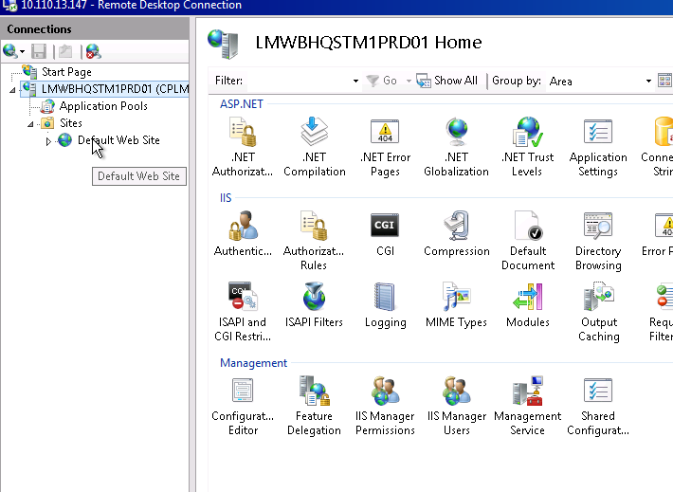

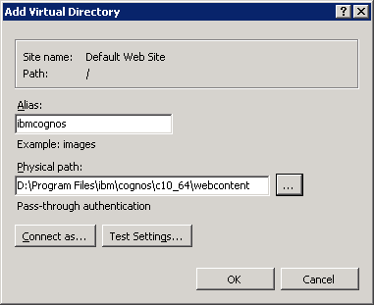

Add Virtual Directory to ibmCognos as **cgi-bin**path install_directory

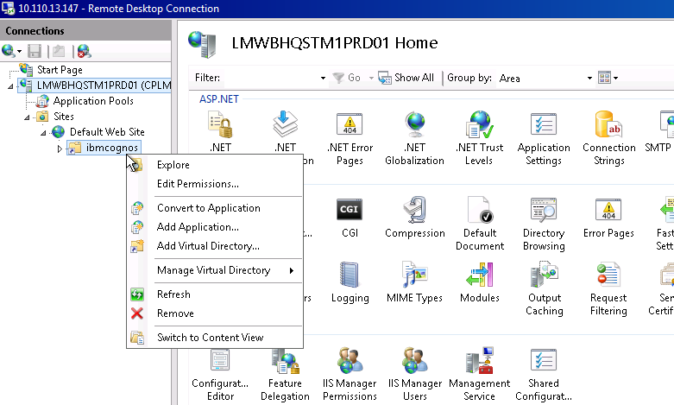

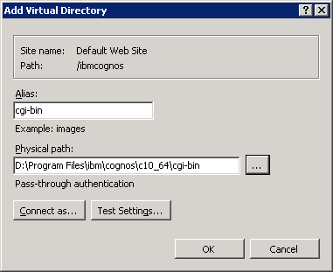

Add Module Mapping for CGI and ISAPI Extension

Double Click on Handler Mappings under Default Web site pane

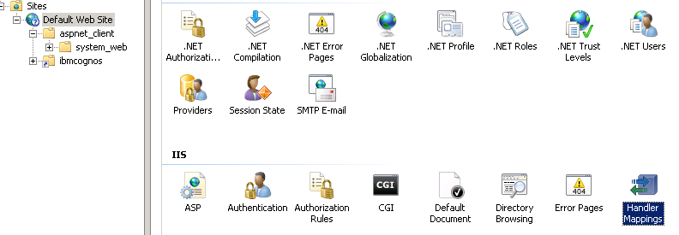

Click on Add Module Mapping for Cognos

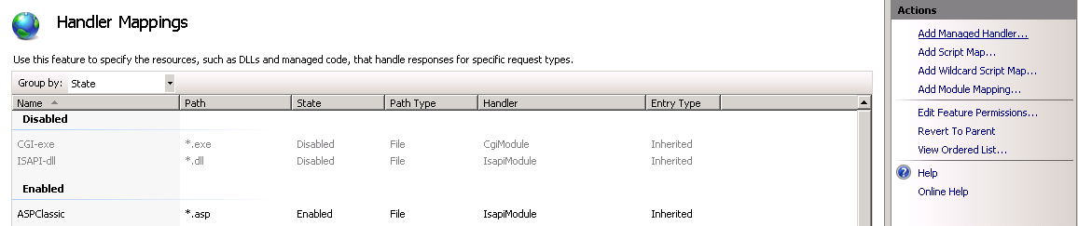

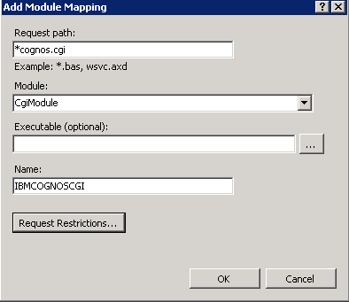

Provide permission access as Execute

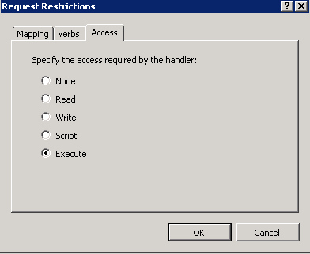

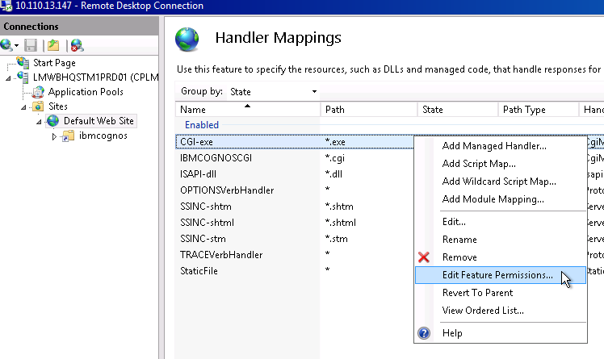

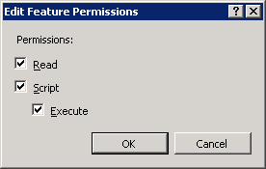

Repeat the Module Mapping steps to configure URL on ISAPI.DLL extension (If Required).

Add CGI and ISAPI Restrictions

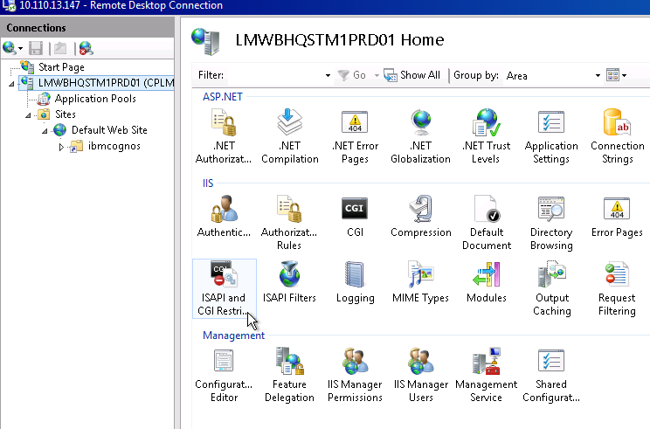

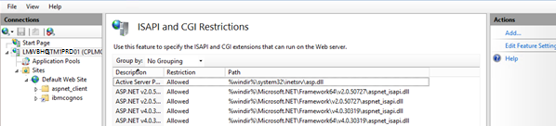

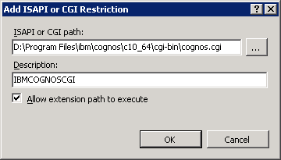

Add Application pool as IBMCOGNOS this will be used later by CGI and ISAPI cognos url

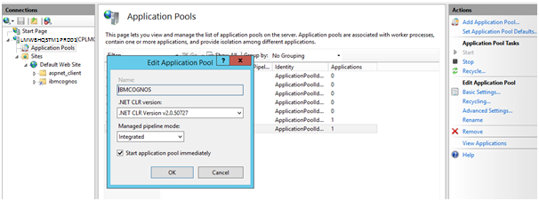

After All configuration cover the **ibmcognos>cgi-bin** virtual directory to Application with IBMCognos Application Pool

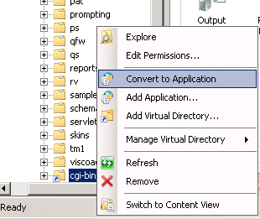

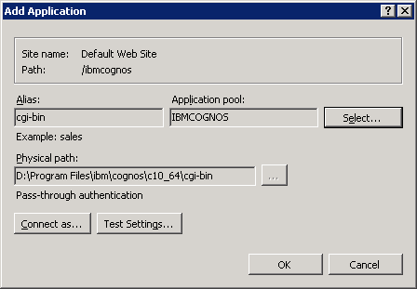

Test both the URL after starting the Cognos BI services

[http://lmcgsweb.cplmg.com:80/ibmcognos/cgi-bin/cognos.cgi](http://s185a0099:80/ibmcognos/cgi-bin/cognos.cgi)

The page appear as default page, if the namespace is configured to Anonymous access,

Else if the AD is configured than this login page appears. Try login in with the required credentials.

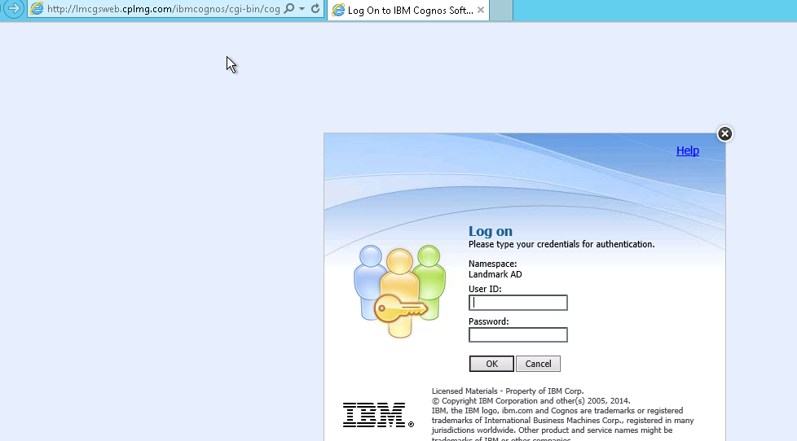

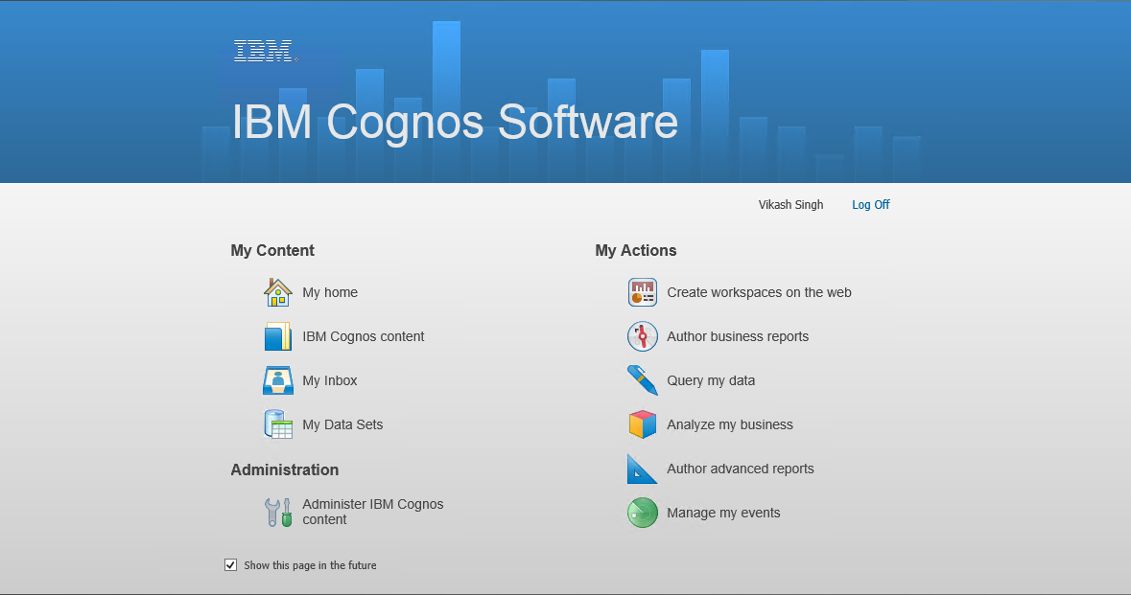

Configure BI to accept TM1 Web server requests (BI-TM1 inter-compatibility)

Extract the Gateway files from TM1 Application folder

Install_directiry\tm1_64\webapps\pmpsvc\gateway_files(For the **TM110.2.1 and below**)

Install_directiry\tm1_64\bi_interop (For the **TM1 10.2.2** and above)

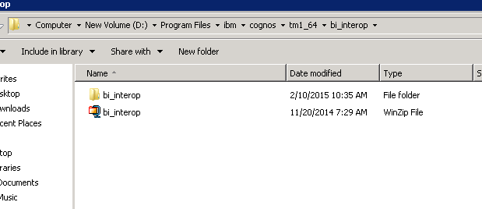

Copy gateway files to respective location of the BI Install_Directory

|  |  |
| --- | --- |
| Source Folder and file | Destination Folder |
| \templates\ps\portal\variables_plan.xml | \c10_64\templates\ps\portal |
| \webcontent\planning.html | \c10_64\webcontent |
| \webcontent\ps\portal\images\icon_active_application.gif | \c10_64\webcontent\ps\portal\images |
| \webcontent\icd\feeds\images\icon_active_application.gif | \c10_64 webcontent\icd\feeds\images |
|  |  |

Note: In case of distributed architecture, we will place these files in both the servers i.e. 10.110.13.148 where BI is installed as well as on 10.110.13.147 where BI Gateway (Web) is installed.

Update the BI Install Location Files with TM1 Application URL

Open **Planning.html** in folder **\c10_64\webcontent**

Open **tm1web.html** in folder**\c10_64\webcontent\tm1\web**

update the Planning Service Variable and TM1 Service parameter in respective files as

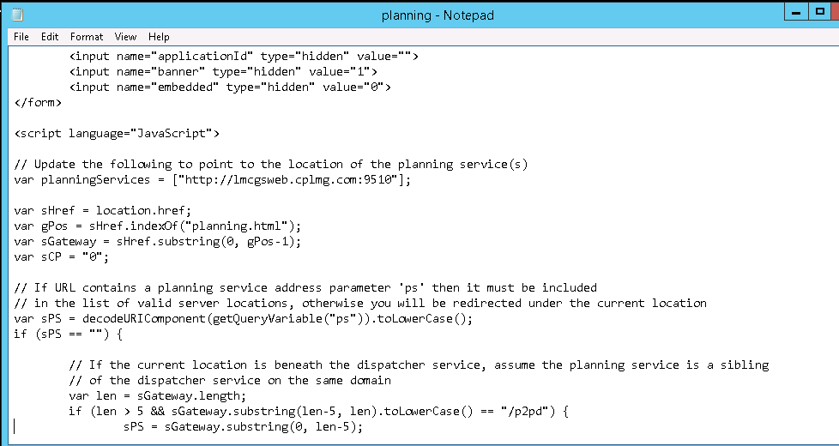

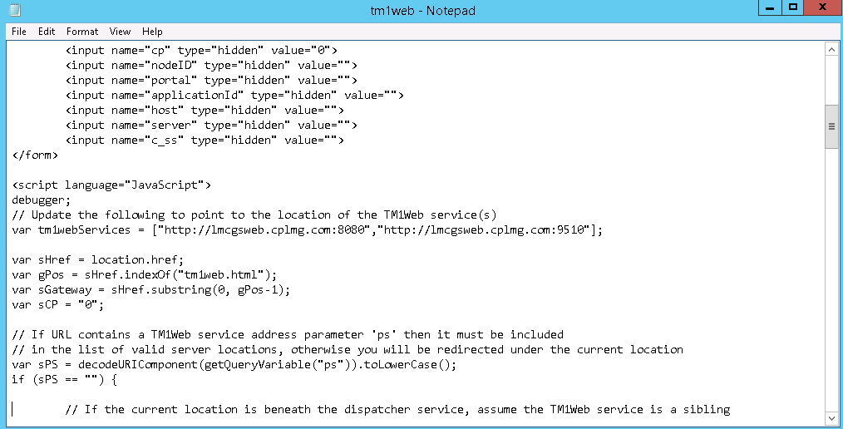

For multiple entries for the servers put **“,”** in between as,

**var planningServices = [“http://hostname:9510”,“http://IP:9510”, “http://localhost:9510”];**

**var tm1webServices = [“http://hostname:9510”,“http://IP:9510”, “http://localhost:9510”];**

Create backup Copy **variables_TM1.xml.sample** file in **\c10_64\templates\ps\portal**

Rename the file as **variables_TM1.xml**

Update Variable_TM1.xml file (This change is specific to TM1Web Urls)

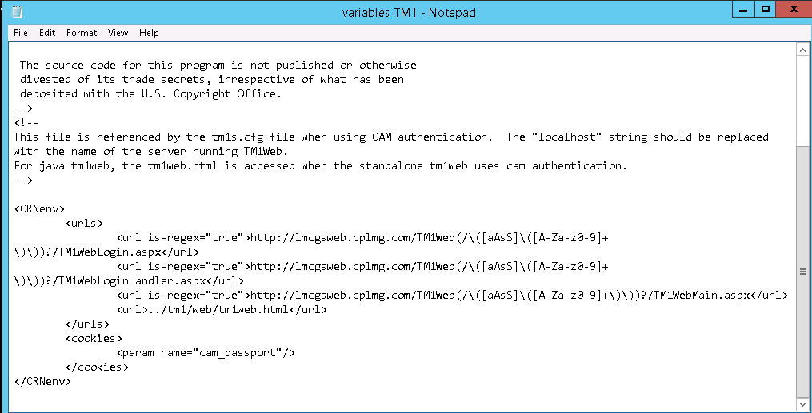

Change the 3 localhost with the host name or Server IP or internet Url as show

Installation of Cognos TM1 along with Fix pack 3

Install Cognos TM1 Server Components

Go to software folder and open the TM1 installation kit



Navigate to win64> issetup.exe Run with “Run As Administrator” option on right click it

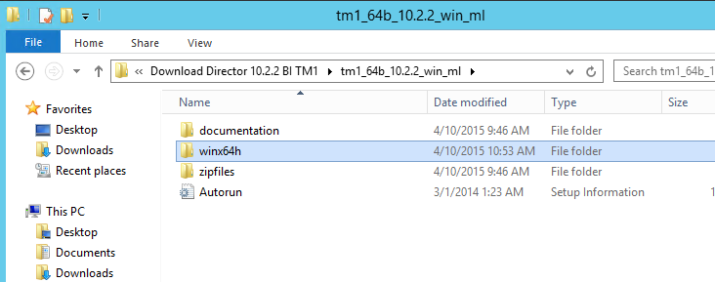

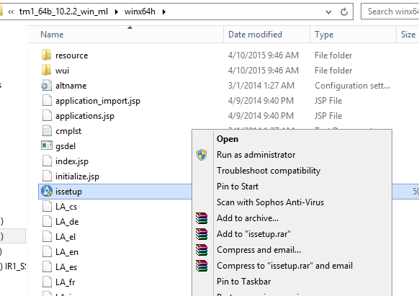

Click on the next till the component selection (**If required you can change the Drive for installation in the folder path step**)

Select all the components for **single server configurations**, for **Distributed architecture** please follow below component selection.

|  |  |  |  |  |
| --- | --- | --- | --- | --- |
| **Component Name on the Installation Kit** | **Web Server** | **TM1 App Server** | **TM1 Admin Machine** | **TM1 Client** |
| **TM1 Application Tier** |  |  |  |  |
| TM1 Admin Server |  |  |  |  |
| TM1 Server |  |  |  |  |
| TM1 Tools |  |  |  |  |
| **Web Application Tier** |  |  |  |  |
| TM1 Application Gateway |  |  |  |  |
| TM1 Application Server |  |  |  |  |
| TM1 Web |  |  |  |  |
| TM1 Operational Console |  |  |  |  |
| **TM1 Client Tier** |  |  |  |  |
| TM1 Perspective (MS Excel interface) |  |  |  |  |
| Cognos Insight |  |  |  |  |
| TM1 APIs |  |  |  |  |
| **Developer Tier** |  |  |  |  |
| TM1 Architect |  |  |  |  |
| TM1 Performance Modeler |  |  | Screen ClippingScreen ClippingScreen ClippingScreen ClippingScreen ClippingScreen ClippingScreen ClippingScreen ClippingScreen ClippingScreen ClippingScreen ClippingScreen ClippingScreen ClippingScreen ClippingScreen ClippingScreen ClippingScreen ClippingScreen ClippingScreen Clipping |  |
| **Optional Installations** |  |  |  |  |
| Samples (optional) |  |  |  |  |
| Translated Documentation (optional) |  |  |  |  |

**Note Special Case: -** For Multiple TM1 Application Servers to cater to only one Admin Server We need to install TM1 application server without Admin Server component.

Finish the installation and Start configuration as per below order,

1stTM1 application server (where Admin server is first than others)

2nd TM1 Web server

3rdTM1 Admin Machine

4thTM1 Client Machine

Start IBM Cognos Configuration for respective servers

So as in Landmark (Production) we have distributed server we will install the components as below.

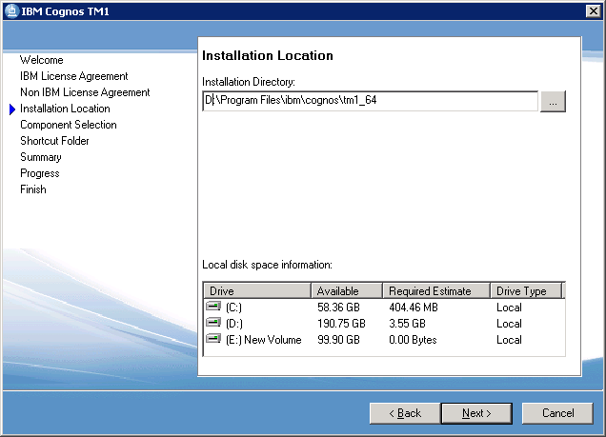

This is on Server 10.110.13.147 - Gateway and Web Application Tier Components would be installed

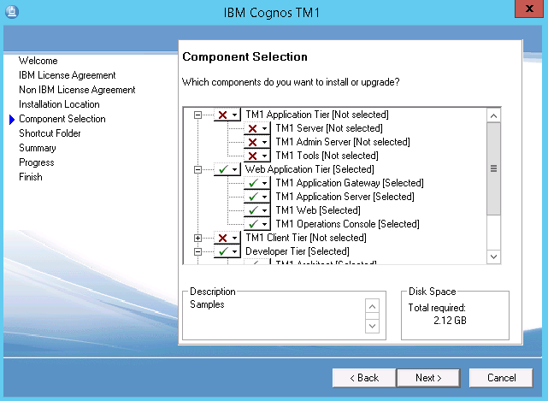

On Server 10.110.13.133 We will install the Admin Server and TM1 Server

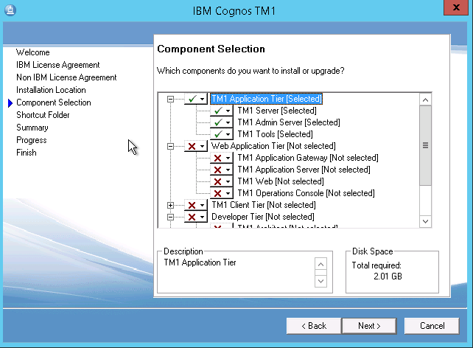

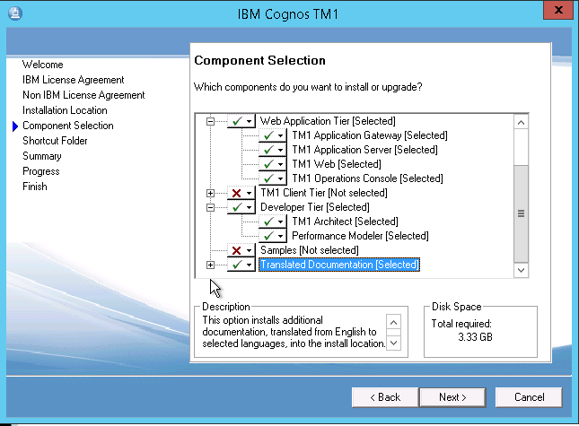

For the Translated Documentation , You can select the required language documentation if required.

Configure the IBM Cognos TM1 Components

Start the IBM Cognos Configuration(Run as Administrator) for TM1 Admin Server and Web server components,

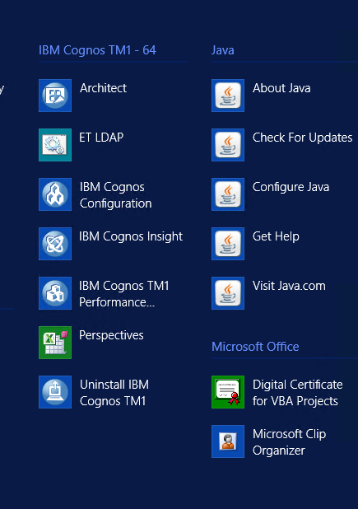

Put the **server IP** or **Server hostname** or **Server fully qualified domain name** or **Internet site** where you have LOCALHOST,

In Environment Tab

Provide the Cognos BI urls (Note TM1 only supports cognos.cgi url does not support cognosisapi.dll)

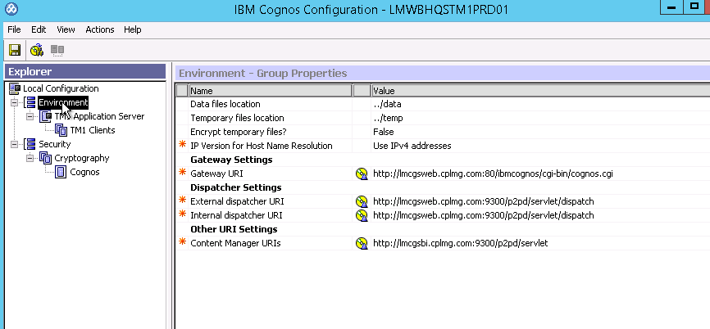

In Application Server Tab (TM1 web Server details)

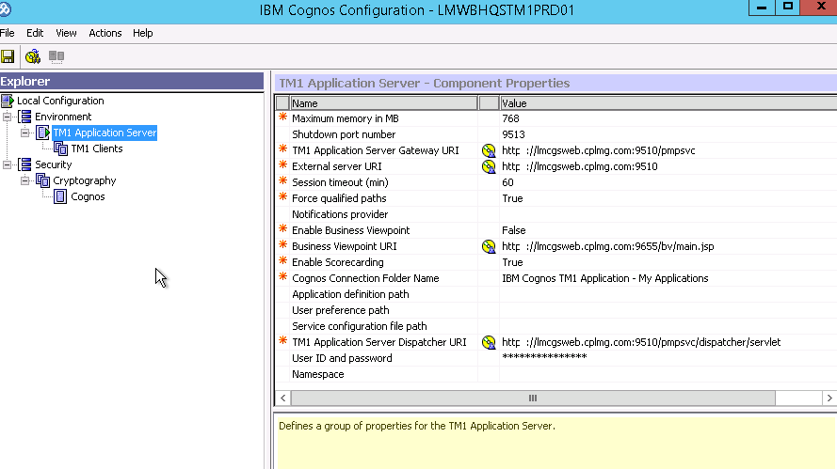

**Important Note**: - This Tab will define that TM1 Web and TM1 Applications will run on which URLs and Port, User need to specify the given URLs on their browser to access the respective TM1 views or applications. The default port is 9510 can be changed to any other port as well but as best practice followed as 9510 only for HTTP as well as HTTPS (SSL) connections.

For **TM1 Client** and **Admin Server** Tabs keep the default setting not to change any parameter for all standard installation cases

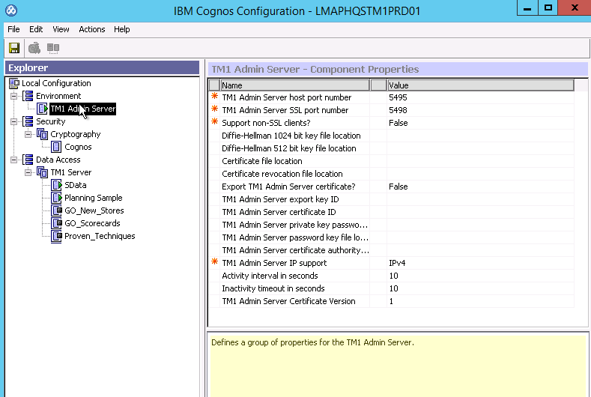

We get 3 sample TM1 servers configured with the installation as default. We can start the cognos Services with above configure to validate and work with default configurations.

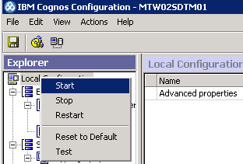

It will register all the required Services and start the same.

Stop all the service the same way and we can proceed to Install FP3.

Upgrade the TM1 10.2.2 with the Fix Pack3

Note:- The fix pack 2 is not installed because it is already carried in the fix pack 3. This means all the upgrade of the fix pack2 is there in fix pack3

* + - 1. Installing fix pack 3

It is the same process as we followed for the TM1 10.2.2

Fixed pack 3 will be installed on all servers having TM1 Components.

Open the Folder :- **up_plananalytics_win64h_10.2.5230.146_ml.tar**

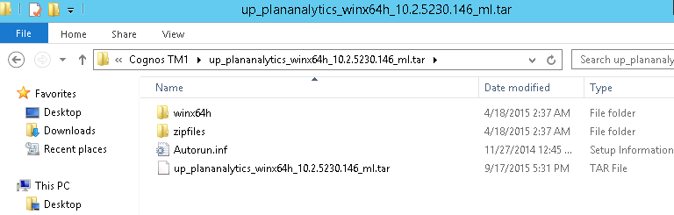

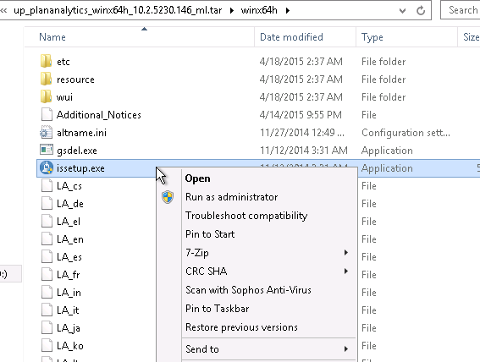

Run it as Administrator and do the installation in the same location where the Pervious installation was done.

Do next > next and Install the FP3

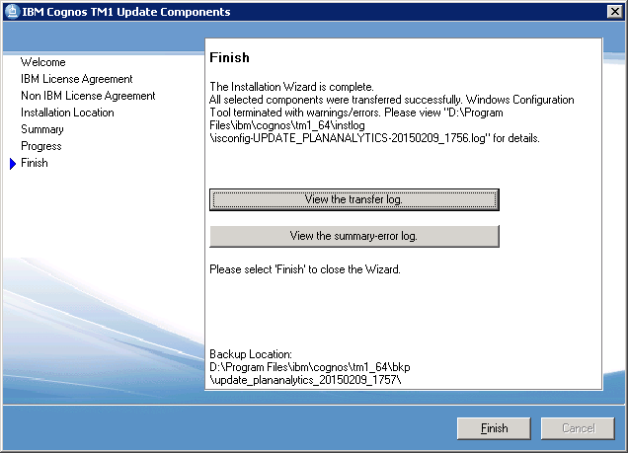

When done this screen will appear.

Run the Cognos Configuration and Start the services. Say yes if asked to save the configuration.

Run the Architect Client

To Test everything is running perfect we will open the TM1 Architect Client and see all the default server running under the given Admin Server,

Go To All programme > IBM Cognos TM1 - 64 > Architect > Run As Administrator

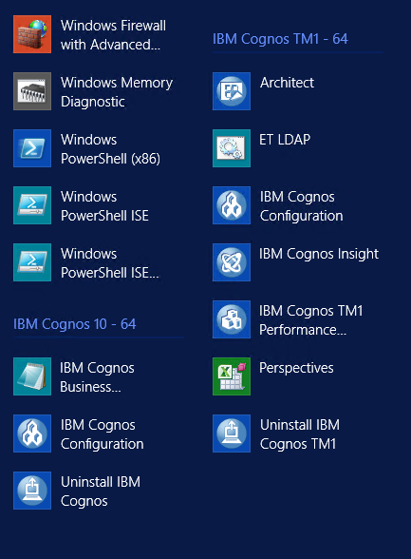

We will get all the servers running on the TM1 Admin Server specified,

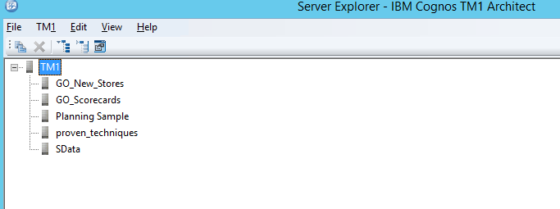

To change the admin Server please follow below steps to update the configurations,

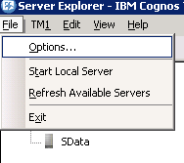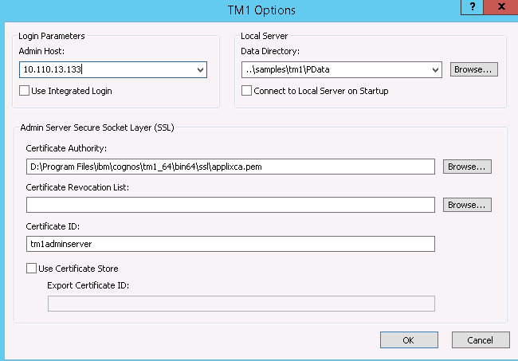

We mention it as 10.110.13.133 because the Admin server is situated on that server.

Run the TM1 Application and TM1 Web for the first time

Open the Internet Explorer and put the TM1 application URLs as,

<http://servername:9510/pmpsvc>

**eg**. [http://lmcgsweb.cplmg.com:9510/pmpsvc](http://s185a0099/pmpsvc)

Provide the Admin Server and TM1 Server credentials and click Ok

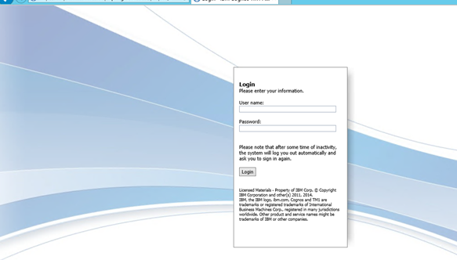

Add new TM1 Server as Landmark_Prod

Create TM1 Server as Landmark_Prod

Create Folder for the new TM1 Server to required location

E:\Landmark_Prod

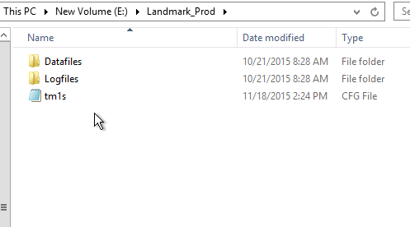

Create two subfolders as DataFiles and LogFiles under the Landmark_Prod location

**Open IBM Cognos Configuration**

Right Click on TM1 Server tab

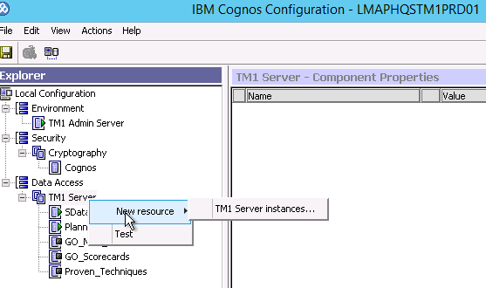

Provide a name as

**Landmark_Prod**

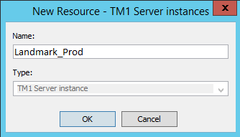

Provide the full path of Landmark folder where we are going to put the TM1S.cfg file for the Landmark_Prod server.

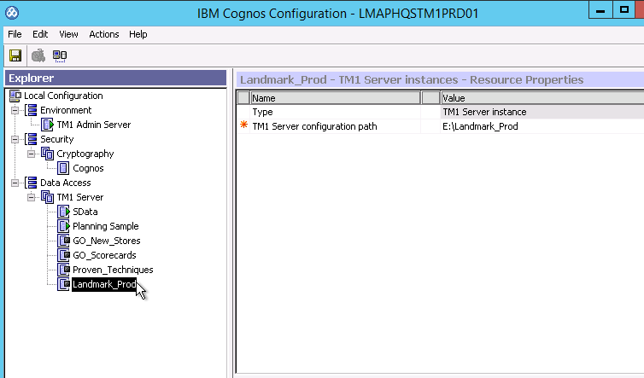

Start the New Server by right click Start

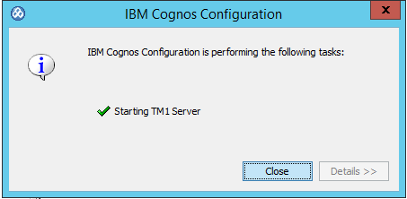

This will configure the Landmark_Prod as service and create the default files to given location.

Stop the Landmark_Prod server to change the default parameters in the TM1S.cfg file,

Go to Landmark_Prod folder and Move All the files and folder accept DataFiles, LogFiles and TM1S.cfg file to Landmark_Prod> DataFiles folder. Move the all .log file from DataFiles to LogFiles folder

Open the TM1S.cfg file with Notepad > Run As Administrator,

Search and Change Following Parameters as,

DataBaseDirectory=E:\Landmark_Prod\DataFiles

AdminHost=AdminServerIP or DomainName

PortNumber=31342

Add a New parameter to point the Log file to LogFiles folder

LoggingDirectory=E:\Landmark_Prod\LogFiles

Go to the IBM Cognos Configuration and start the Services of Landmark and Open Architect to login to the Server

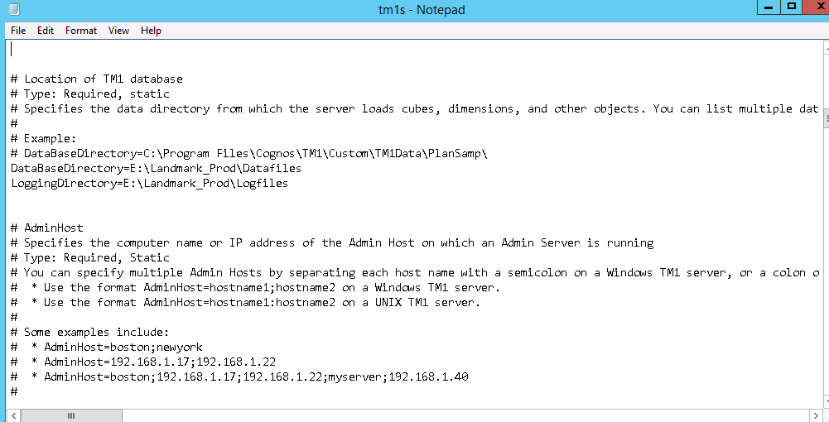

Open the Landmark_Prod which you have created

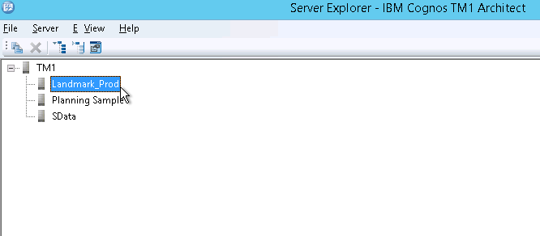

For the first time login to the Server using Id **Admin** without any password, the server will able to load the default list of the items

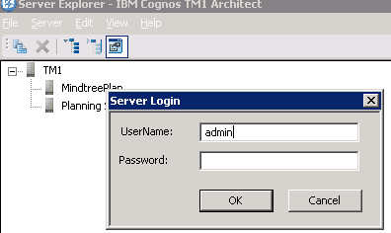

Change the TM1 Server to point to IBM Cognos BI Security

For this to achieve first you need to configure the TM1 server to run on IntergratedSecurityMode **1**, native security.

Change Architect .ini file to load BI Security groups

To Change the Architect Parameters to accept the BI URL and fetch groups from BI Security.

Open the TM1P.ini file located in user’s roaming profile,

C:\Users\”OS **LOGINUSR”**\AppData\Roaming\Applix\TM1

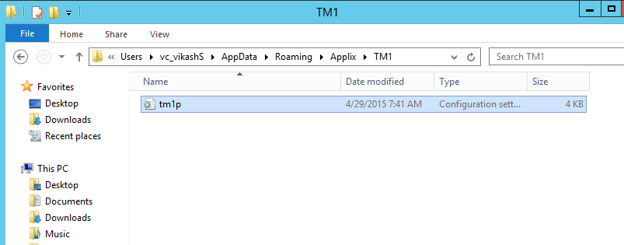

Change following parameter in .ini file

AdvancedRulesEditor = T

AllowImportCAMClients = T

CognosGatewayURI = [http://hostname/ibmcognos/cgi-bin/cognos.cgi](http://s185a0099/ibmcognos/cgi-bin/cognos.cgi)

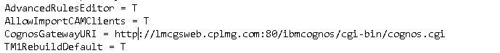

**Note**: - This parameter change is required to be done all the admin servers or machine from which we need to the assign or add Cognos BI Groups or Clients.

Add Cognos BI Admin Group to Server

Open Architect and Login to TM1 server Landmark on Sec Mode 1

Login and Open the Security > Client/Group …

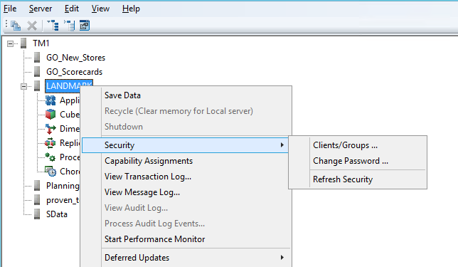

Go To Add Groups,

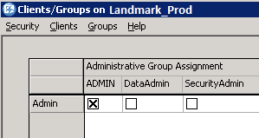

Provide Login credentials for the Cognos BI/AD login, add the required Groups to the IBM Cognos TM1 server.

We first put the **Planning Rights Administrator or create a New Group with name Landmark Administrator** Group as TM1 Admin Group and the **Landmark\Cognos** user an Admin Client,

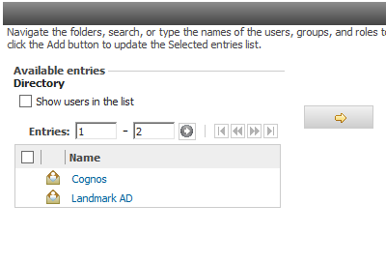

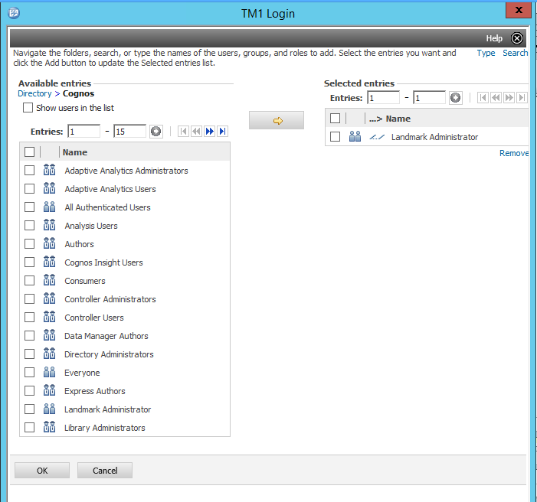

Assign the Cognos Administrator to Admin Group and TM1 Admin User(vc_Vikashs) to Cognos\Planning Rights Administrators or the new Group created Landmark Administrator's ,

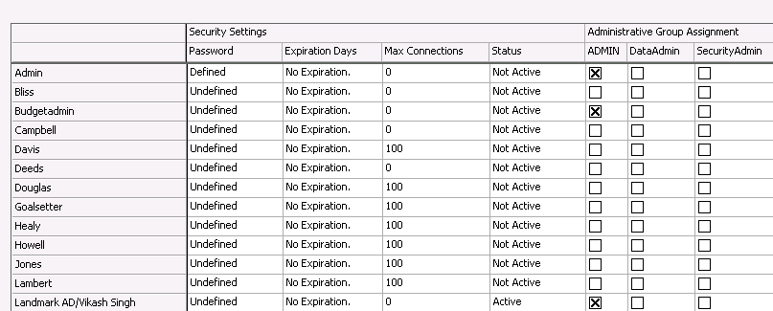

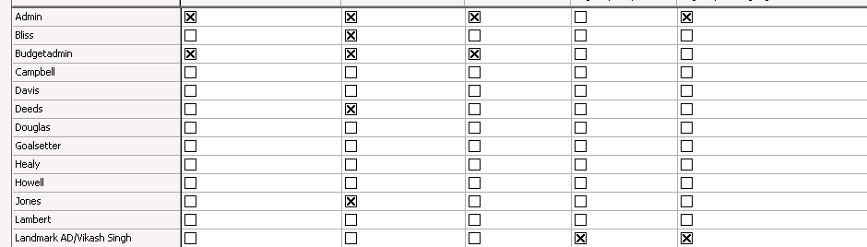

Click Ok, Save data to TM1 server and Refresh security

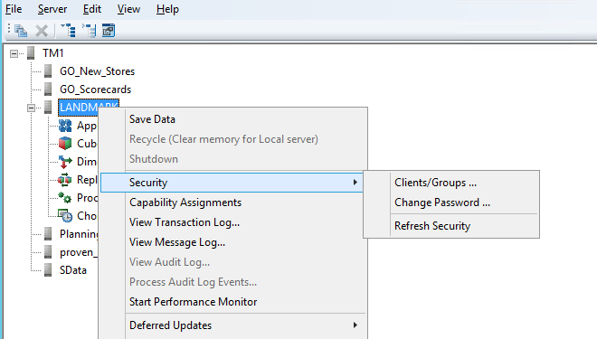

Close the architect Stop the Landmark_Prod Server,

Change the Landmark_Prod to run on BI security

Landmark_Prod server should use only BI User to login and Groups from BI and TM1 namespace,

To enable that open the TM1S.cfg file from Landmark_Prod folder and update following parameters to the file,

IntegratedSecurityMode=5

ServerCAMURI=http://lmcgsweb.cplmg.com:9300/p2pd/servlet/dispatch

ClientCAMURI=http://lmcgsweb.cplmg.com:80/ibmcognos/cgi-bin/cognos.cgi

ClientPingCAMPassport=900

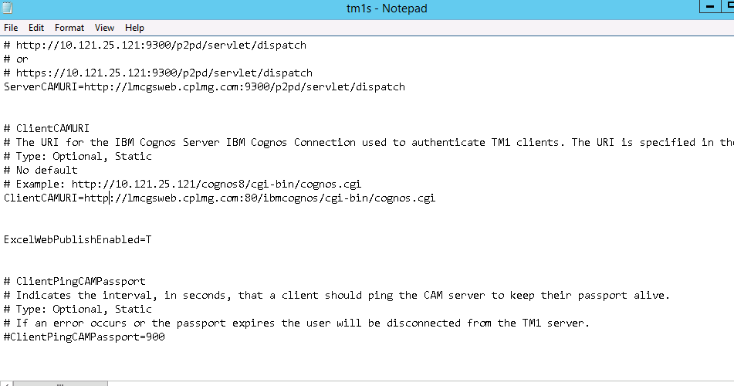

Check the TM1 Server with IBM Cognos BI Security

Start the Landmark Server and login to architect with Cognos Administrator User ID to Check the access

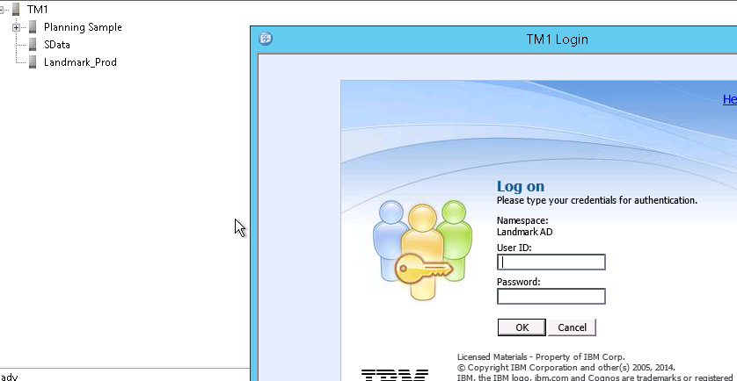

Check as we are able to Load the Cubes, Dimensions, Processes etc

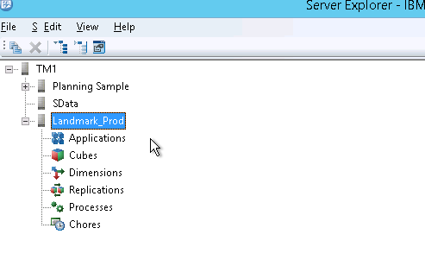

Update TM1 Application Config file to accept the BI Urls

Open the fpmsvic_config.xml file in **\tm1_64\webapps\pmpsvc\WEB-INF\configuration**

**Add following lines to <TM1> section or update id they are already there with other Hostname or IPs**

<tm1>

<gateway uri =”http:// lmcgsweb.cplmg.com/ibmcognos/cgi-bin/cognos.cgi "/>

<dispatcher uri="http://lmcgsbi.cplmg.com:9300/p2pd/servlet/dispatch"/>

..

..

..

</tm1>

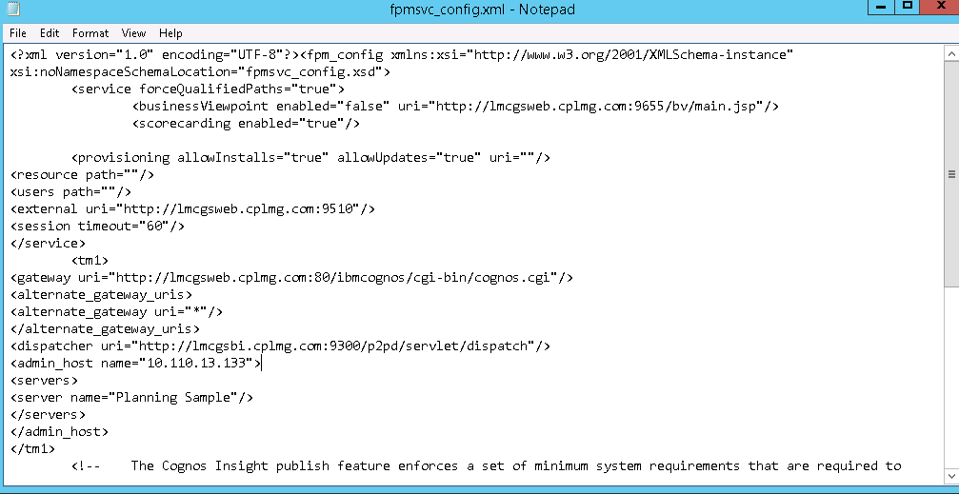

Restart the IBM Cognos TM1 Application Server to reflect the above changes

Configure Cognos BI on SSL

Before configuring any component on SSL make sure that it is running perfectly in the Non SSL environment in all the aspects of the configurations and usage

**Before you begin**:

Run Command Prompt with **Run As Administrator** Option

Please verify the environment variable JAVA_HOME path pointing to **“cognos_install\c10_64\bin\jre\7.0\”**

or run the tool with command **java:local**

or set the JAVA_HOME on the runtime command prompt. Set JAVA_HOME= “..\cognos_install\c10_64\bin\jre\7.0\”

Default IBM Keystore password is **NoPassWordSet** which is used to all the commands and IBM Configurations

Copy all the Certificate to folder install_directory\c10_64\bin\ssl for reference purpose

Also copy the certificates to **…\cognos\c10_64\bin** and **…\cognos\c10_64\bin64** folders

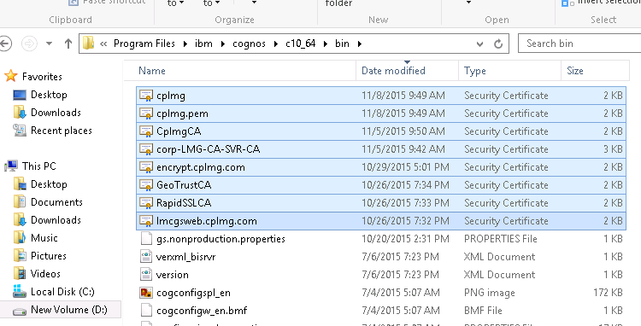

You need to Run the ThirdPartyTool.bat file with the following command:

**ThirdPartyCertificateTool.bat -T -i -r *certificate_fileName* -D ../configuration/signkeypair -p *password***

Import the certificates in to the respective trust stores

Import the Certificates to IBM Cognos Keystores,

Import encrypt.cplmg.com.cer

ThirdPartyCertificateTool.bat -java:local -T -i -r encrypt.cplmg.com.cer –p NoPassWordSet

Import RapidSSLCA.cer

ThirdPartyCertificateTool.bat -java:local -T -i -r RapidSSLCA.cer –p NoPassWordSet

Import GeoTrustCA.cer Similarly import all the certificates

ThirdPartyCertificateTool.bat -java:local -T -i -r GeoTrustCA.cer –p NoPassWordSet

Similarly import all the certificates.

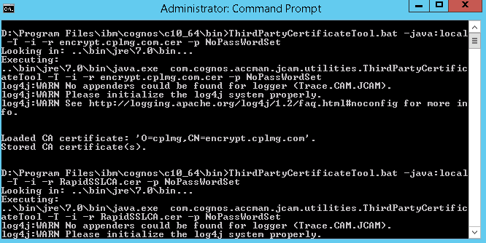

Import Certificate to Windows Key Store

Go to start > run> mmc

Add Snap In tool,

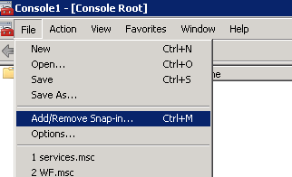

Select the Certificate from the Left pane and add to the Right pane as selection

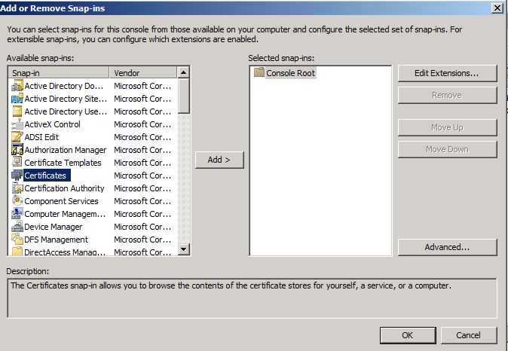

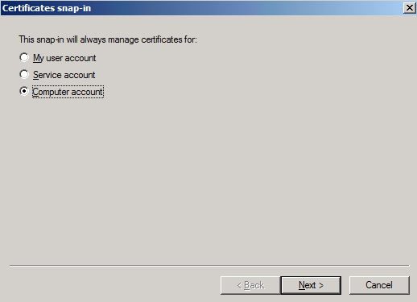

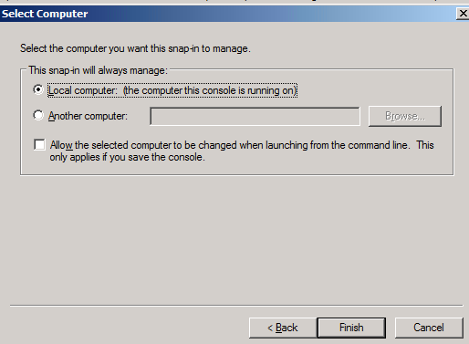

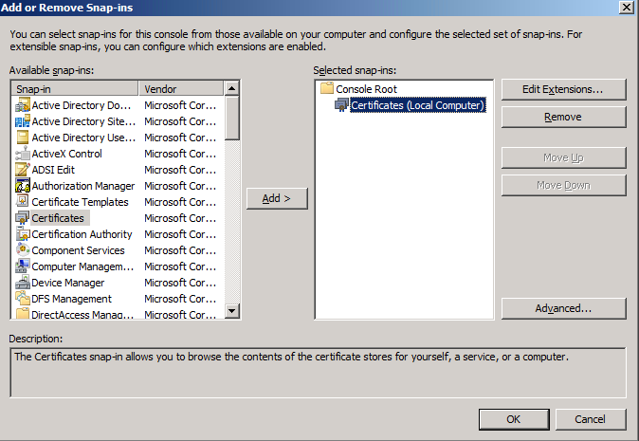

The MMC will open the Certificate store of the Windows, Add the CA certificate and the other certificates to the Windows Trusted stores,

Add all the certificates in the Trusted Root Certificates

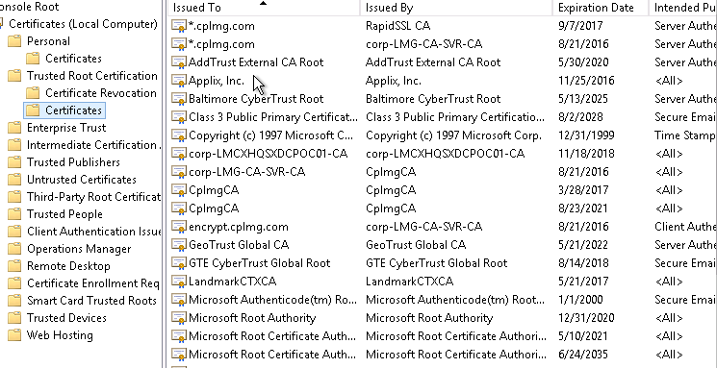

Update the IIS settings

Open the IIS configurations,

Start > Run > inetmgr

Import Certificate

Click on the Webserver page and Open the Certificates tabs,

Check the *.cplmg.com certificate will be imported there,

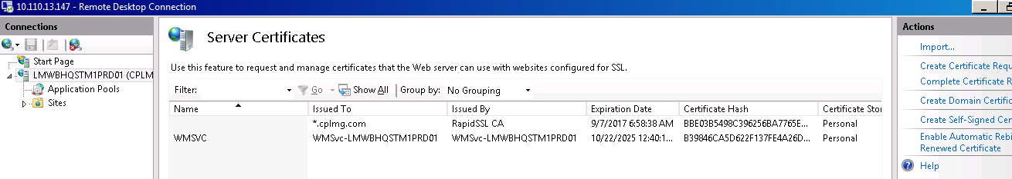

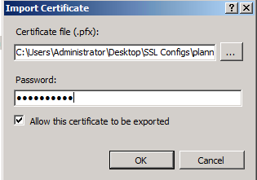

Edit Bindings Certificates

Right click on Default Site > Edit Binding

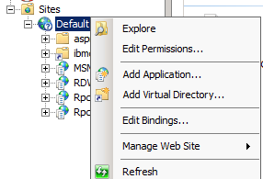

Add a Bindings as HTTPS for port 443 and Select the certificate as **\*.cplmg.com**

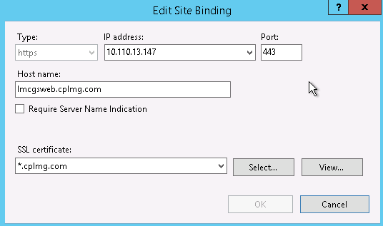

**Note**: - If the HTTPS binding is already exist change the certificate to the **\*.cplmg.com** from the existing one

Change the ibmcognos virtual directory to access only over SSL,

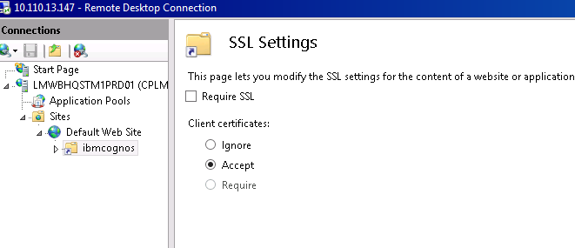

Change the URLs in Cognos Configurations

Update the URLs for the IBM Cognos to required URL,

For Landmark the BI Web Gateway site it is considered as,

[https://lmcgsweb.cplmg.com:443/ibmcognos/cgi-bin/cognos.cgi](https://planning.mindtree.com:443/mplan/cgi-bin/cognos.cgi)

Screenshot

Update the configuration on BI Gateway (10.110.13.147)

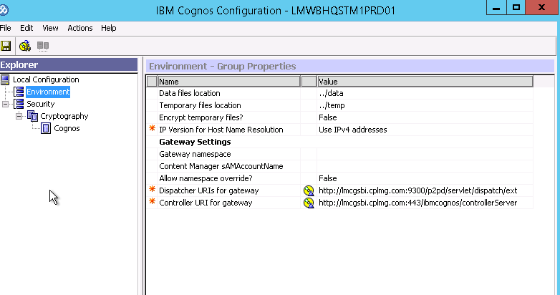

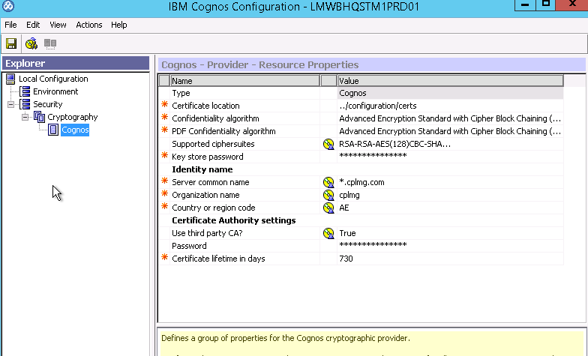

Check BI URLs with SSL

Restart the Cognos BI services and Check with below URLs

[https://lmcgsweb.cplmg.com:443/ibmcognos/cgi-bin/cognos.cgi](https://planning.mindtree.com:80/mplan/cgi-bin/cognos.cgi)

https:// lmcgsweb.cplmg.com::443/ibmcognos/cgi-bin/cognosisapi.dll

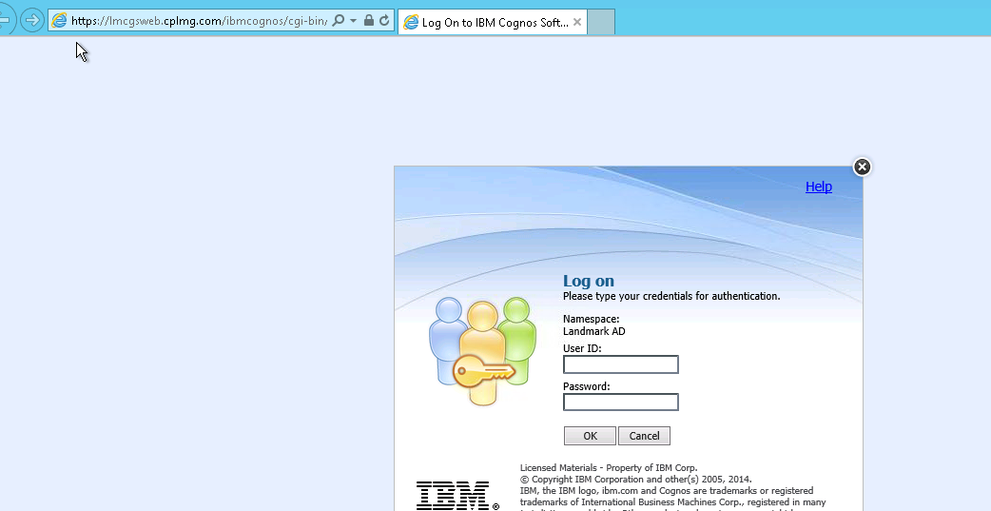

Note: When deploying application and accessing it from the Contributor web (pmpsvc) the application might not load fully and may get stuck on the tm1web screen.

To resolve this issue,

1 - Navigate to TM1_Install_Dir/bin64/jre/7.0/bin   
  
2 - Import the server certificate into the cacerts keystore using the following command:   
  
keytool -import -alias root -keystore "TM1_INSTALL_DIR\bin64\jre\7.0\lib\security\cacerts" -trustcacerts -file “path to your server certificate"

i.e. keytool import -alias corp-lmg-ca-svr-ca -keystore "D:/Program Files/ibm/cognos/tm1_64/bin64/jre/7.0/lib/security/cacerts" -trustcacerts -file "D:/Program Files/ibm/cognos/tm1_64/bin64/ssl/corp-LMG-CA-SVR-CA.cer"

Keystore password for cacerts is **changeit**

Configure Cognos TM1 Web Application Server on SSL

**Before you begin**

* Please ensure that everything and required TM1 servers are running on Application server using Non SSL mode Url.
* Stop the TM1 Application services
* In all the cases Run the command prompt from D:\ Drive with Run as Administrator option
* After completion of the SSL setup you need to re-deploye all the TM1 applications from the Performance modeler

Create a Certificate Key in the New Keystore.

Open the JDK tool which host the Tomcat application and its SSL configuration

<TM1_Install>\tm1_64\bin64\jre\7.0\bin folder **Keytool.exe** in command prompt

Command is,

keytool -genkey -alias *.cplmg.com -keyalg RSA -keysize 1024 -keystore "D:\Program Files\ibm\cognos\tm1_64\bin64\ssl\keystorecplmg"

**Note**: - the above command will also create the **keystorecplmg** in the respective location if not available. Provided the Keystore password as “**NoPassWordSet**”(Welcome2016) this will be used all the places for Mindkeystore. This password need to be used in all the commands where the Mindkeystore is taken in to consideration.

Provide the certificate details as requested, the output of the command will look as below on command prompt

What is your first and last name?

[Unknown]: *.cplmg.com

What is the name of your organizational unit?

[Unknown]: Finance

What is the name of your organization?

[Unknown]: cplmg

What is the name of your City or Locality?

[Unknown]: Dubai

What is the name of your State or Province?

[Unknown]: AE

What is the two-letter country code for this unit?

[Unknown]: AE

Is CN=*.cplmg.com, OU=Finance, O=cplmg, L=Dubai, ST=AE, C=AE cor

rect? (type "yes" or "no")

[no]: y

Enter key password for <keystorecplmg>:

(RETURN if same as keystore password):

Create the Certificates requests

In the command prompt navigate to <TM1_Install>\tm1_64\bin64\jre\7.0\bin

Run below command to generate the Certificate request on the Certificate key we generated with a name *.cplmg.com

keytool -certreq -keyalg RSA -alias *.cplmg.com -file planning.csr -keystore "D:\Program Files\ibm\cognos\tm1_64\bin64\ssl\keystorecplmg"

ThirdPartyCertificateTool.bat -java:local -c -s -r sign.csr -d "CN=sign.cplmg.com, O=cplmg" -D "D:\Program Files\ibm\cognos\tm1_64\configuration\signkeypair" -p NoPassWordSet

ThirdPartyCertificateTool.bat -java:local -c -e -r encrypt.csr -d "CN=encrypt.cplmg.com, O=cplmg" -D "D:\Program Files\ibm\cognos\tm1_64\configuration\encryptkeypair" -p NoPassWordSet

Look for the **planning.csr, encrypt.csr, sign.csr** file & Provide this file to Certificate authority and get the certificate in .pfx or .cer format

Certificates from CA

Get the following certificates from CA

* Certificate Authority Certificate - cplmg.p7b or cplmg.cer
* Certificate from CA on Certificate request planning.csr & Plan.cer or Planning.pfx

Copy this certificates to following folders

<TM1_Install>\tm1_64\bin64\ssl

<TM1_Install>\tm1_64\bin\ssl

<TM1_Install>\tm1_64\webapps\pmpsvc\WEB-INF\bin64\ssl

In case of Wildcard Certificate, make sure the certificate has a full detailed hierarchy to it, i.e. RapidSSL-->GeoTrustSSL.

Also, make sure that the csr/cer which is provided to the CA is approved by the internal CA.

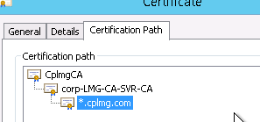

Import the certificates in to the respective truststores

In the command prompt navigate to <TM1_Install>\tm1_64\bin64\jre\7.0\bin

keytool -importcert –trustcacerts -alias *.cplmg.com -file "D:\Program Files\ibm\cognos\tm1_64\bin64\ssl\cplmg.pem" -keystore "D:\Program Files\ibm\cognos\tm1_64\bin64\ssl\keystorecplmg"

Validate the Keystore with the given certificate, the output will look a like

keytool -list -keystore "D:\Program Files\ibm\cognos\tm1_64\bin64\ssl\keystorecplmg"

**Similarly, import all the certificates**.

keytool -importcert –alias GeoTrustCA -trustcacerts -file "D:\Program Files\ibm\cognos\tm1_64\bin64\ssl\GeoTrustCA.pem" -keystore "D:\Program Files\ibm\cognos\tm1_64\bin64\ssl\keystorecplmg"

Enter keystore password:

Certificate was added to keystore

keytool -importcert –alias RapidSSLCA -trustcacerts -file "D:\Program Files\ibm\cognos\tm1_64\bin64\ssl\RapidSSLCA.pem" -keystore "D:\Program Files\ibm\cognos\tm1_64\bin64\ssl\keystorecplmg"

Enter keystore password:

Certificate was added to keystore

keytool -importcert –alias corp-lmg-ca-svr-ca -trustcacerts -file "D:\Program Files\ibm\cognos\tm1_64\bin64\ssl\corp-lmg-ca-svr-ca.pem" -keystore "D:\Program Files\ibm\cognos\tm1_64\bin64\ssl\keystorecplmg"

Enter keystore password:

Certificate was added to keystore

keytool -importcert –alias encrypt.cplmg.com -trustcacerts -file "D:\Program Files\ibm\cognos\tm1_64\bin64\ssl\encrypt.cplmg.com.pem" -keystore "D:\Program Files\ibm\cognos\tm1_64\bin64\ssl\keystorecplmg"

Enter keystore password:

Certificate was added to keystore

keytool -importcert –alias cplmgCA -trustcacerts -file "D:\Program Files\ibm\cognos\tm1_64\bin64\ssl\cplmgCA.pem" -keystore "D:\Program Files\ibm\cognos\tm1_64\bin64\ssl\keystorecplmg"

Enter keystore password:

Certificate was added to keystore

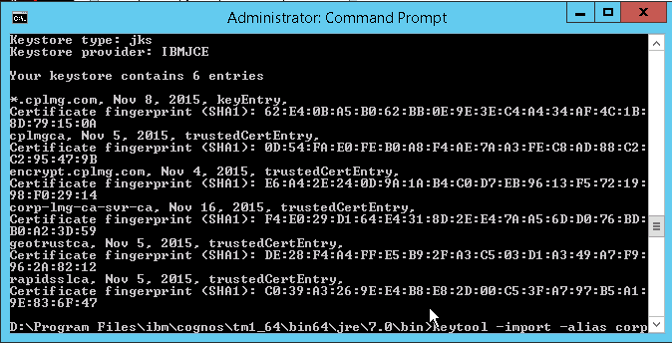

Change the URLs in Cognos Configurations

Change the TM1 Url with SSL

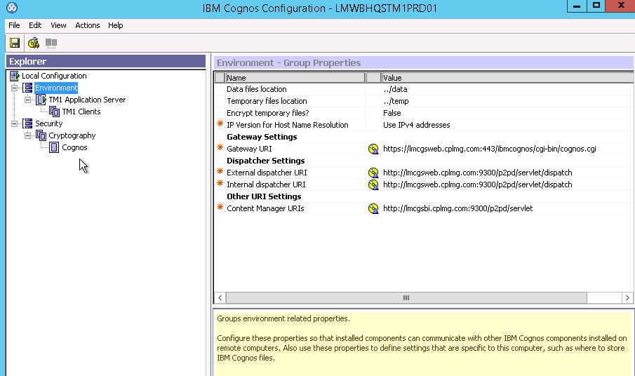

Update the TM1 Application Urls with HTTPS extension, here we have not changed the port 9510 so need not to update the same,

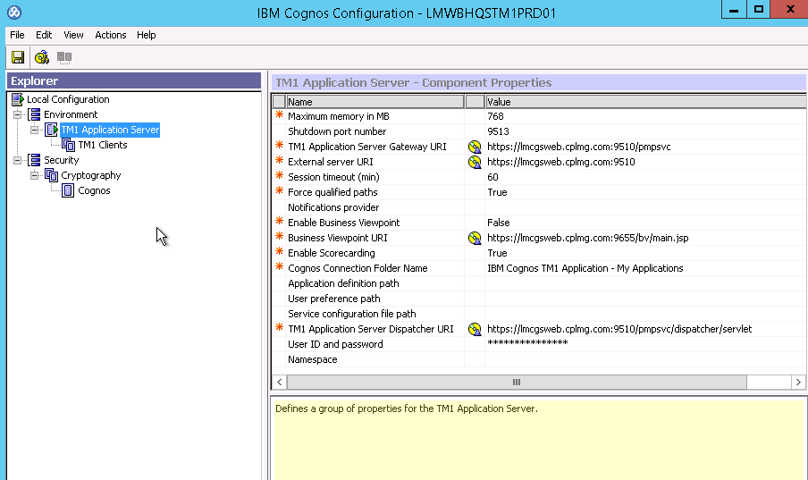

**cy**

Update the Security> Cryptography > Cognos as,

The Password will be as key for the Certificate **\*.cplmg.com** as **NoPassWordSet**

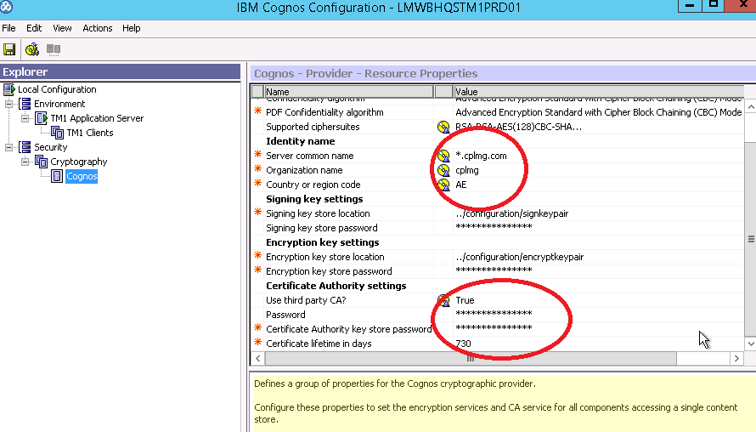

Change the URLs in config files

Update the fpmsvc_config.xml and pmpsvc_config.xml

Navigate to the file **fpmsvc_config.xml** in **…\tm1_64\webapps\pmpsvc\WEB-INF\configuration**

Update the TM1 Application and BI urls to use the Https urls,

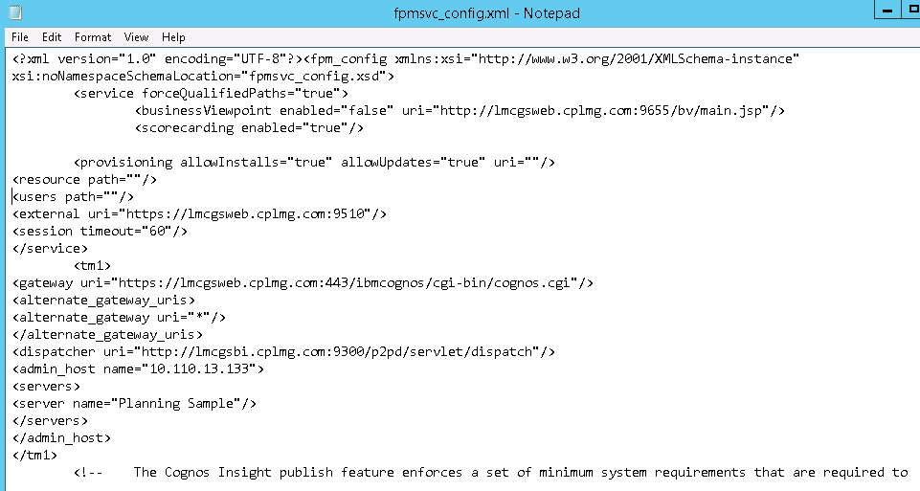

Navigate to the file **pmpsvc_config.xml** in **…\tm1_64\webapps\pmpsvc\WEB-INF\configuration**

Update the TM1 Application and BI urls to use the Https urls,

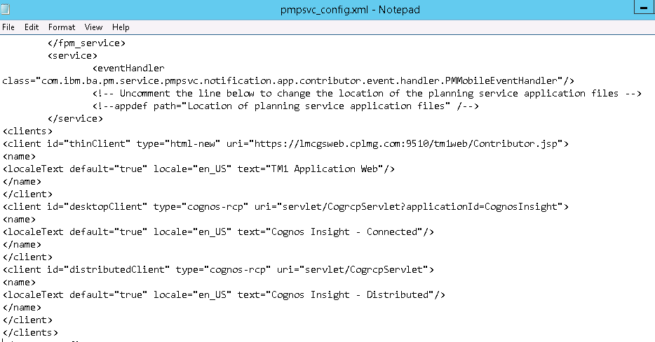

Update the server.xml

Locate the Server.xml file located in …\tm1_64\tomcat\conf,

Look for the following Section in XML code,

*<Connector port="9510" protocol="HTTP/1.1" maxThreads="500" enableLookups="true" acceptCount="500" debug="0" connectionTimeout="60000" disableUploadTimeout="true" maxHttpHeaderSize="16384" URIEncoding="UTF-8" maxProcessors="500" minProcessors="5" useURIValidationHack="false" />*

Add following para in the above xml code, which is for Keystore and Password ref to add,

keystoreFile="D:\Program Files\ibm\cognos\tm1_64\bin64\ssl\keystorecplmg" keystorePass="NoPassWordSet" SSLProtocol="SSLv3" scheme="https" secure="true" SSLEnabled="true"

The final file will as,

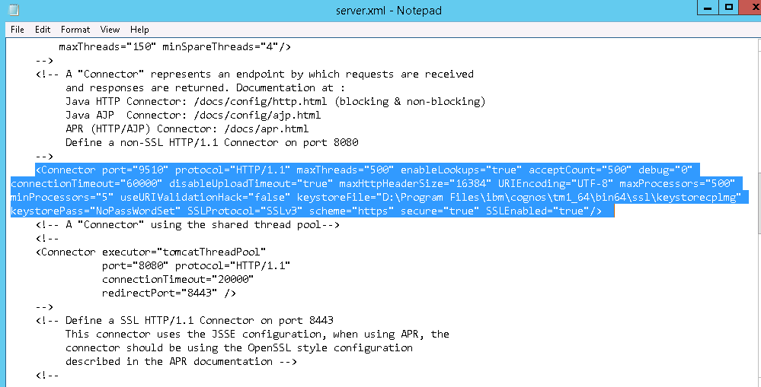

***Very Important Note*: -** *the product has a bug while saving the TM1 Cognos Configuration it adds below parameter in the server.xml,*

***SSLImplementation="com.cognos.accman.jcam.crypto.coyote.JSSEImplementation"***

*This phrase need to be removed manually always if you have saved the TM1 IBM cognos Configurations. Effect of this code will change the certificate from the *.cplmg.com to a default cognos certificate issued by CA issued to CAMUSER.*

Remove this line always after saving TM1 IBM Cognos Configurations and restart the TM1 application services from windows services page not from TM1 IBM Cognos Configurations

Update TM1 Server parameter with BI Url on Htts

Open the TM1S.cfg file for **all the TM1 Servers** and Update the following parameters,

ClientCAMURI=https://lmcgsweb.cplmg.com:443/mplan/cgi-bin/cognos.cgi

CAMSSLCertificate=D:\Program Files\ibm\cognos\tm1_64\bin64\ssl\lmcgsweb.cplmg.com.cer

SkipSSLCAMHostCheck=TRUE

the final file will be as for all the TM1 servers

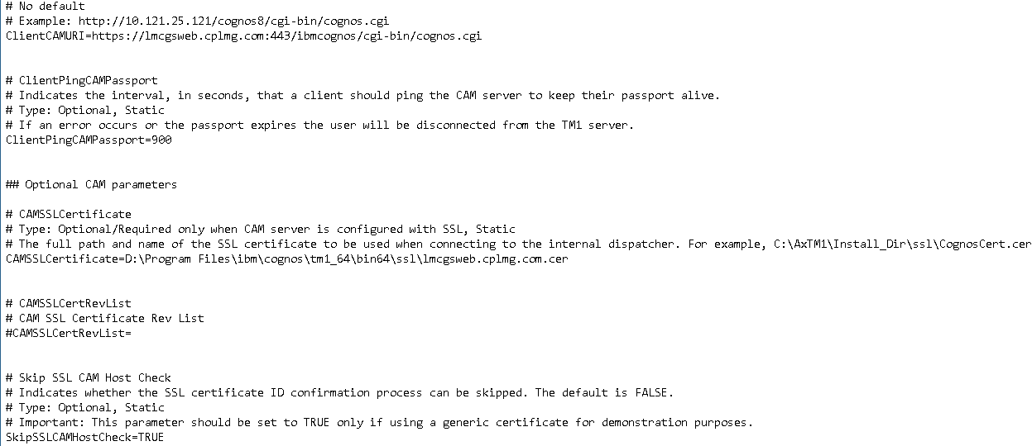

Start the TM1 Server can Restart the TM1 Application server with the change,

Update Architect Client config file TM1P.ini

The TM1P.ini file is located in the users roaming profile,

Locate the C:\users\<***username***>\AppData\Roaming\Applix\TM1

Note: - AppData is a hidden folder so need to activate the view for the Hidden files and folder from the Organise > Folder and Search Option > View > as shown below.

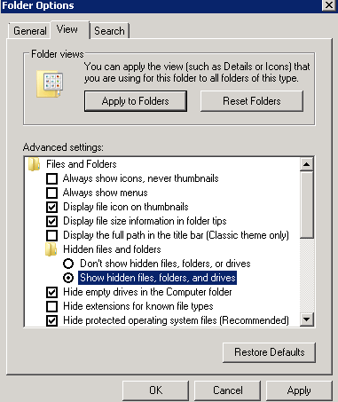

Local the tm1p.ini file and Edit the following parameter as,

CognosGatewayURI = https://lmcgsweb.cplmg.com:443/ibmcognos/cgi-bin/cognos.cgi

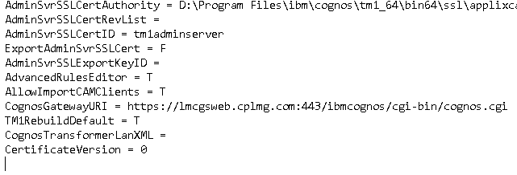

Additional Installations and configurations

The User Guide for the End user’s

The TM1 web URL for the access of the end user’s

The Production server Access

Open IE or the compatible web browser as per the compatibility mentioned in the prerequisites

Enter the URL:-

http:// lmcgsweb.cplmg.com/ibmcognos (BI)

[http:// lmcgsweb.cplmg.com:9510/pmpsvc](http://s185a0100:9510/pmpsvc) (TM1)

Login with the user credentials when the Login page appears

The Development server Access

Open web browser

Enter the URL:-

http:// LMAPDRSTM1UAT01.corp.cplmg.local/ibmcognos (BI)

[http:// LMAPDRSTM1UAT01.corp.cplmg.local:9510/pmpsvc](http://s185a0099:9510/pmpsvc)

Login with the user credentials when the login page appears

Trouble shooting

Cryptography Error while saving the TM1 IBM Cognos Configurations

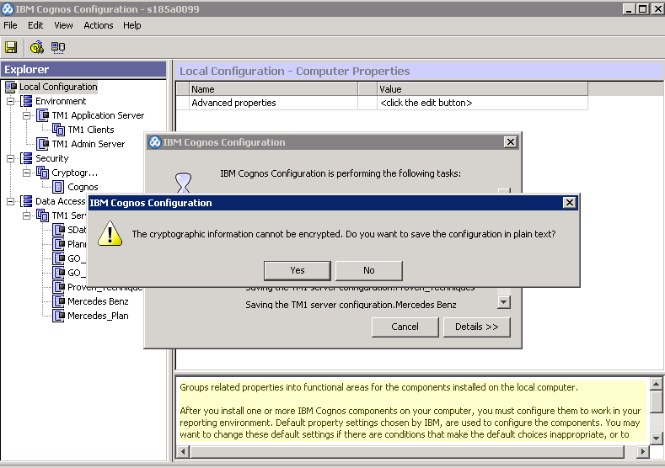

**Steps To solve:-**

Stop Services if on

Close all the IBM Cognosconfiguration

Go to:- D:\Program Files\ibm\cognos\tm1_64\configuration

**TakeBackup**the following filesand **delete** them from the Above folder

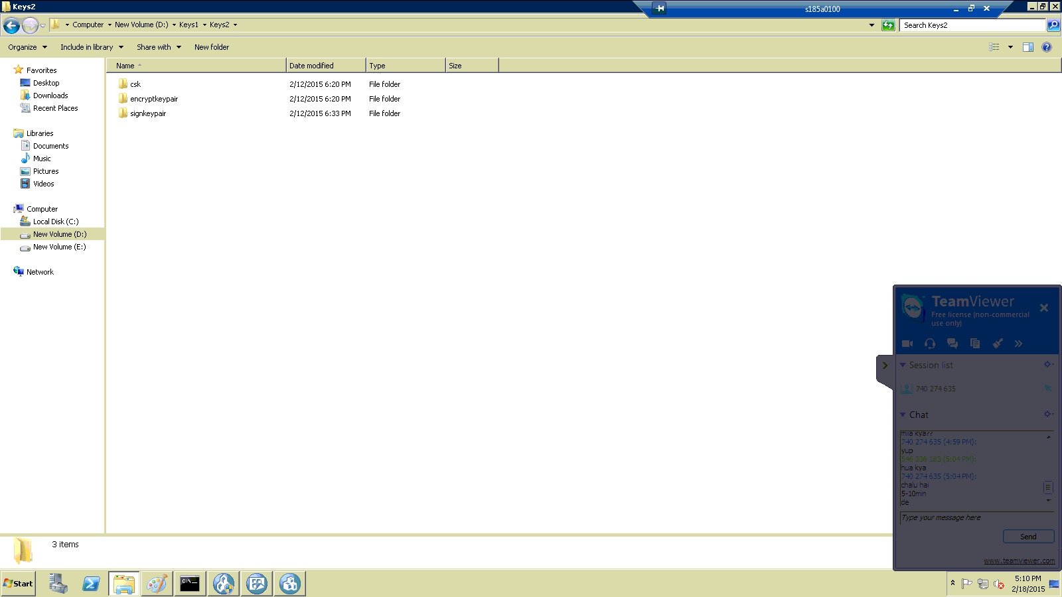

And then save the changes

And now generate the new cryptography

start services

If the Server is not registered in PM

It will show that the logon on failed when the server would not be registered.

So for this u can do it by the manual way .

Steps:-

Open the file

D:\Program Files\ibm\cognos\tm1_64\webapps\pmpsvc\WEB-INF\configuration

Add the server name which ever you want to add



Restart the Services

If Application is not appearing in the web-apps

Steps:-

Stop_Application_server  
Delete pmpsvc folder from

D:\ibm\cognos\tm1_64\tomcat\work\Catalina\localhost\pmpsvc  
  
Start Application Server

Perspective error

File Missing

If the system is facing the file missing error

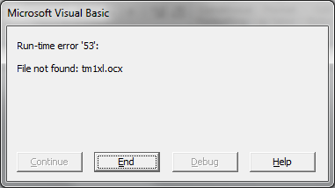

**Other error:-**

**Run-time error '53':File not found: tm1xl.ocx  
Run-time error '53':File not found: tm1prc.dll  
tm1xl.ocx File Not Found**

Refer the following IBM links

<http://www-01.ibm.com/support/docview.wss?uid=swg21649232>

<http://www-01.ibm.com/support/docview.wss?uid=swg21649232>

**Solution :-**

Registering tm1xl.ocx and tm1prc.dll within the bin folder.

Run command prompt as Administrator

Regsvr32.exe /u <directorypath to>\tm1prc.dll tm1xl.ocx

Regsvr32.exe <directorypath to>\tm1prc.dll tm1xl.ocx

Remove third party add-in from Excel

Compatibility Issue

The Above problem can also be because of the compatibility isuue.

Problem:-The perspective(64 bit) and the excel (32 bit)

Solution:-Install the Perspective with the same bit (32bit) configuration as of used for the excel

This will help you solve the issue.

Refer the IBM link:- <http://www-01.ibm.com/support/docview.wss?uid=swg21696075>

The Port Opening Issue

The Applications which we use via web work on the specific ports mentioned in the prerequisites

If the given ports are not opened then the server would give the error as below:-

-server not found

-Error 402

-Error 403